**DB-LAB-TASK-2**

|  |  |
| --- | --- |
| **Roll No: 24P-0706** | **Dept: BS-CS** |
| **Name: Aazan Noor Khuwaja** | **Section : 4B** |

# **ALTER TABLE PART:**

1. **Add a column education_level:**

**Command Input:**

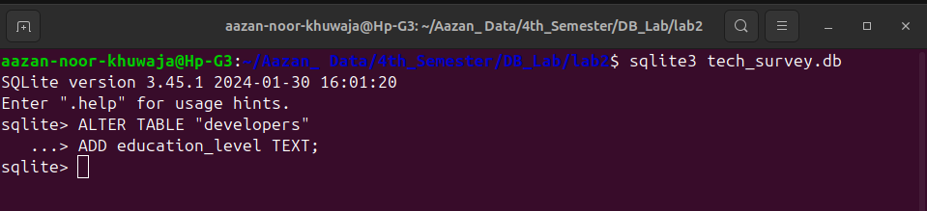

**Command:**

ALTER TABLE “developers”

ADD education_level TEXT;

**Output:**

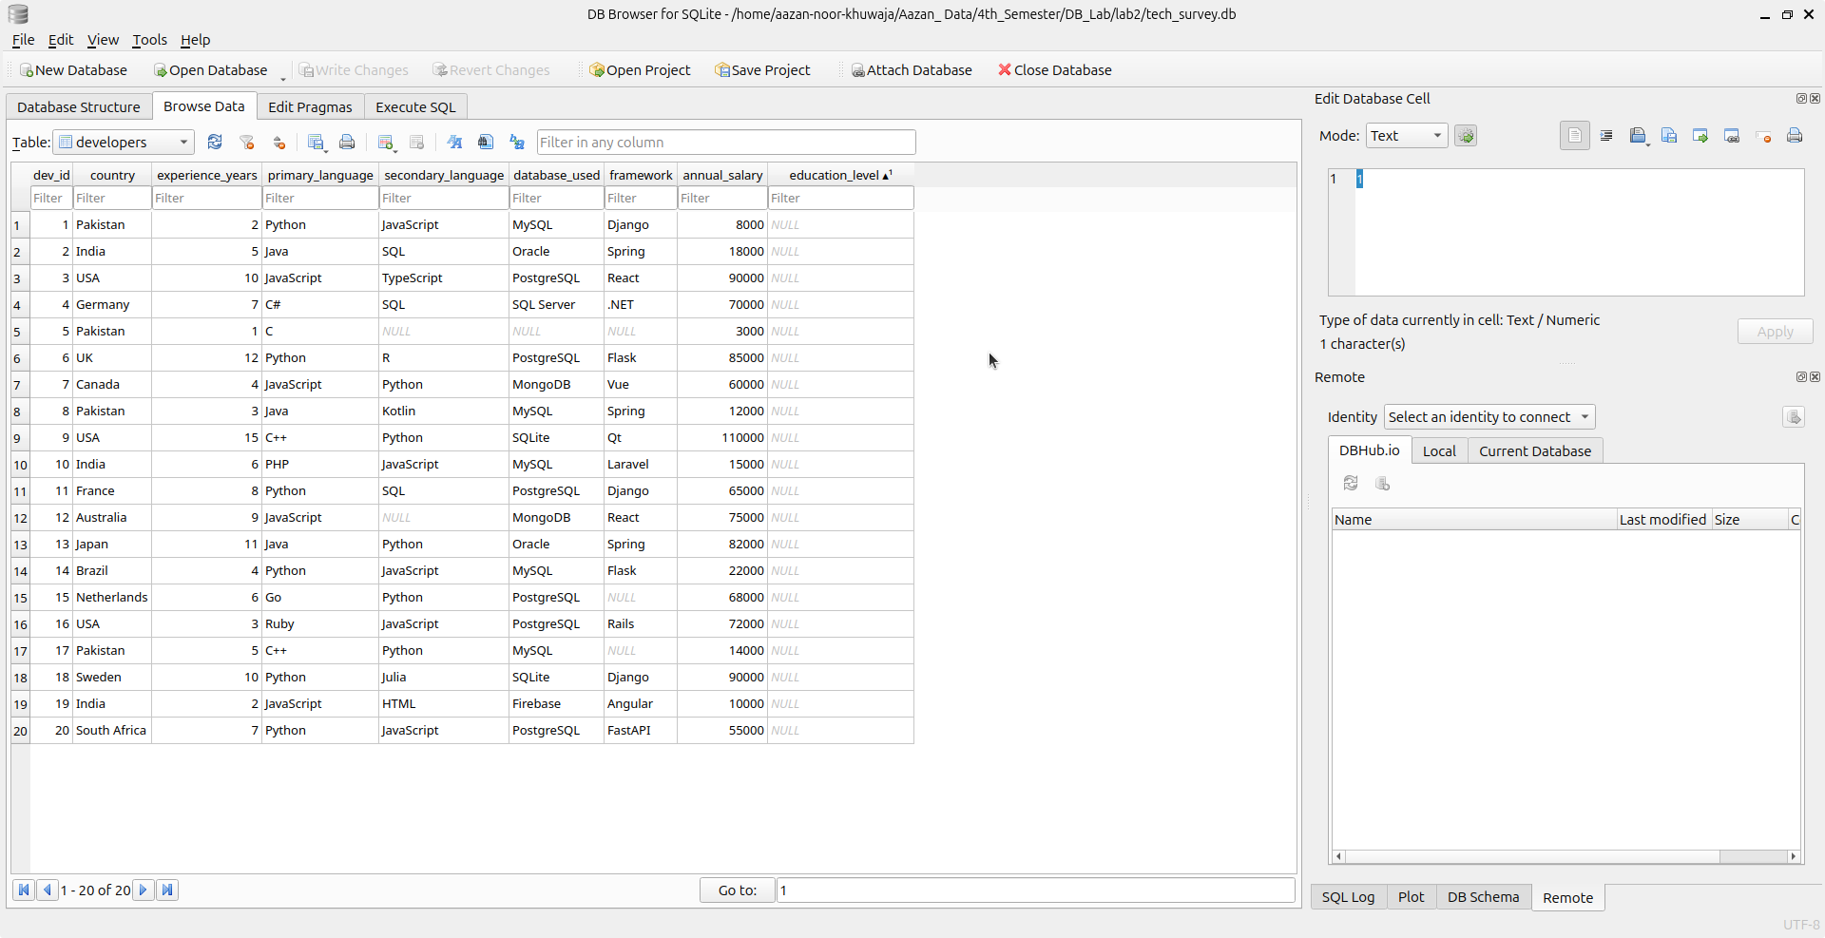

1. **Rename table developers to dev_survey:**

**Command Input:**

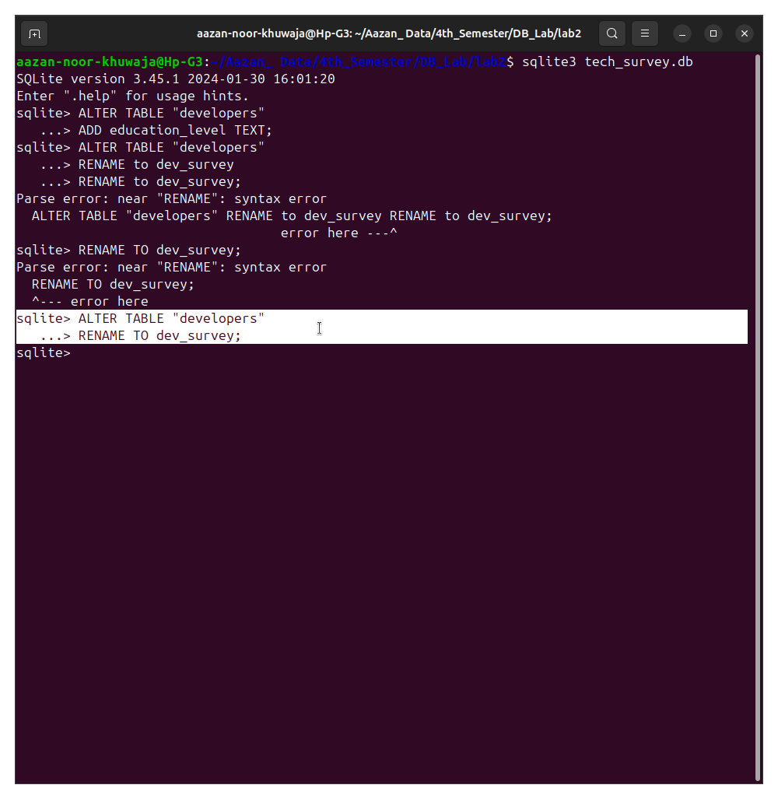

**Command:**

ALTER TABLE "developers"

RENAME TO dev_survey;

**Output:**

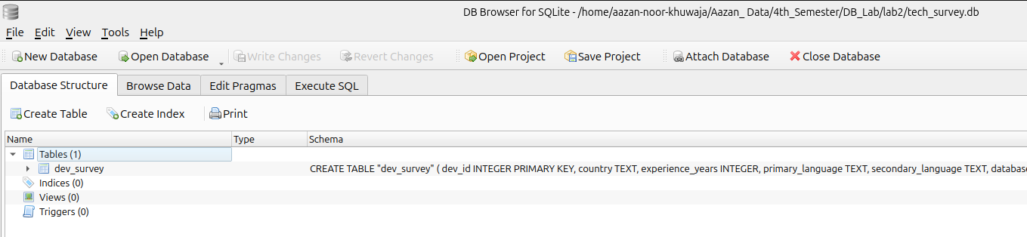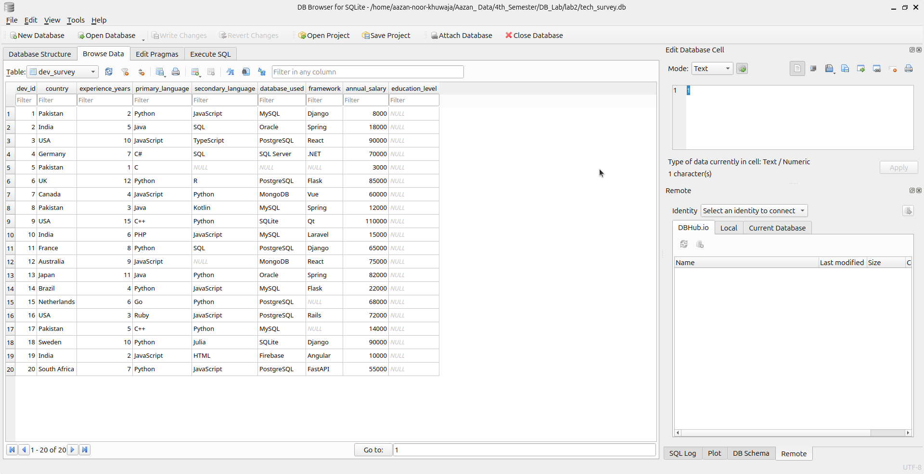

1. **Rename column salary_usd to annual_salary:**

**Command Input:**

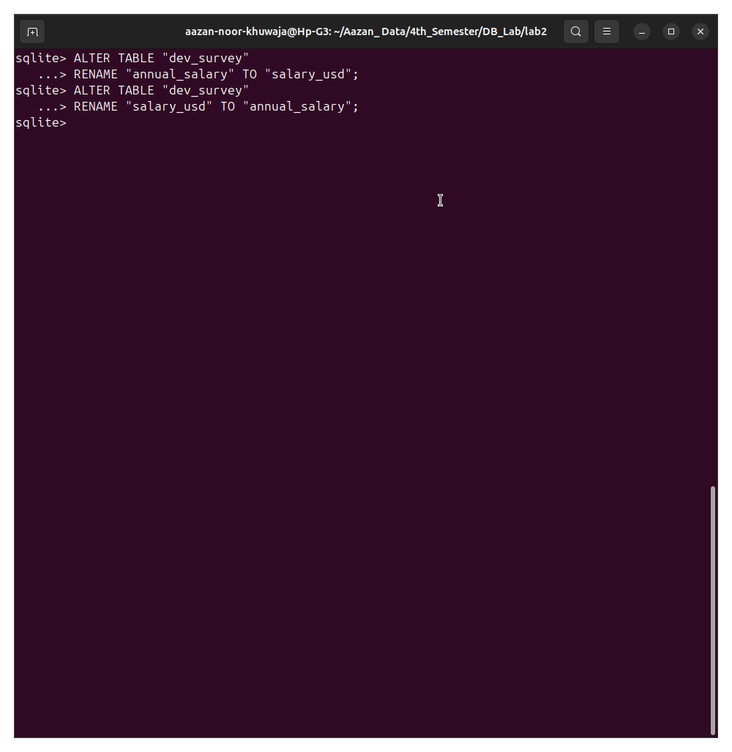

**Command:**

ALTER TABLE "dev_survey"

RENAME "salary_usd" TO "annual_salary";

**Output:**

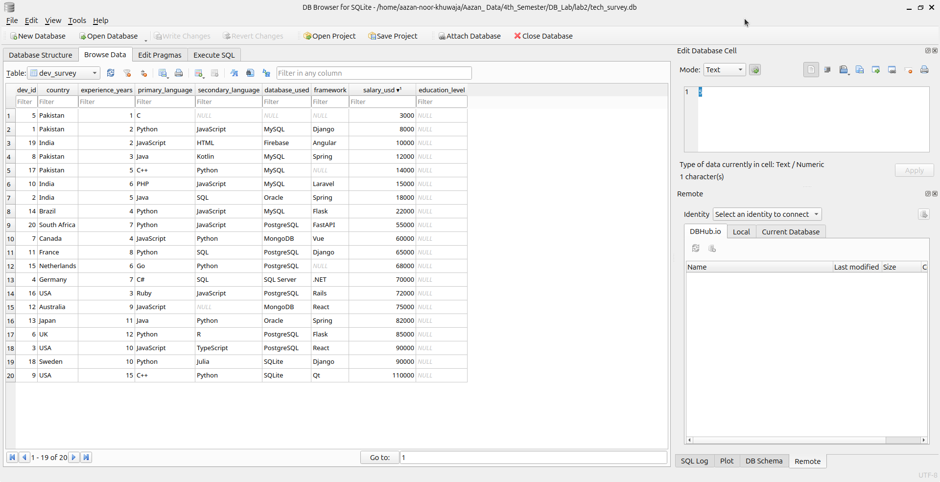

Figure 1 before

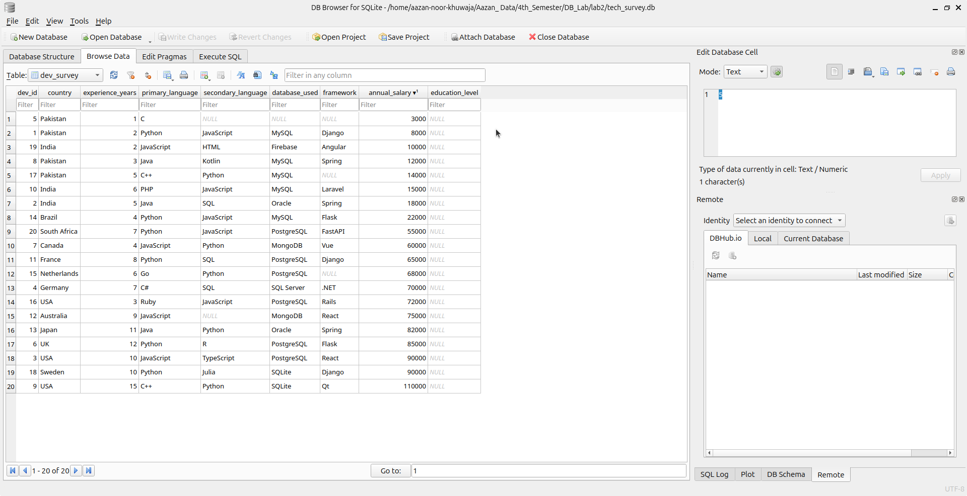

Figure 2 After

1. **Drop column education_level:**

**Command Input:**

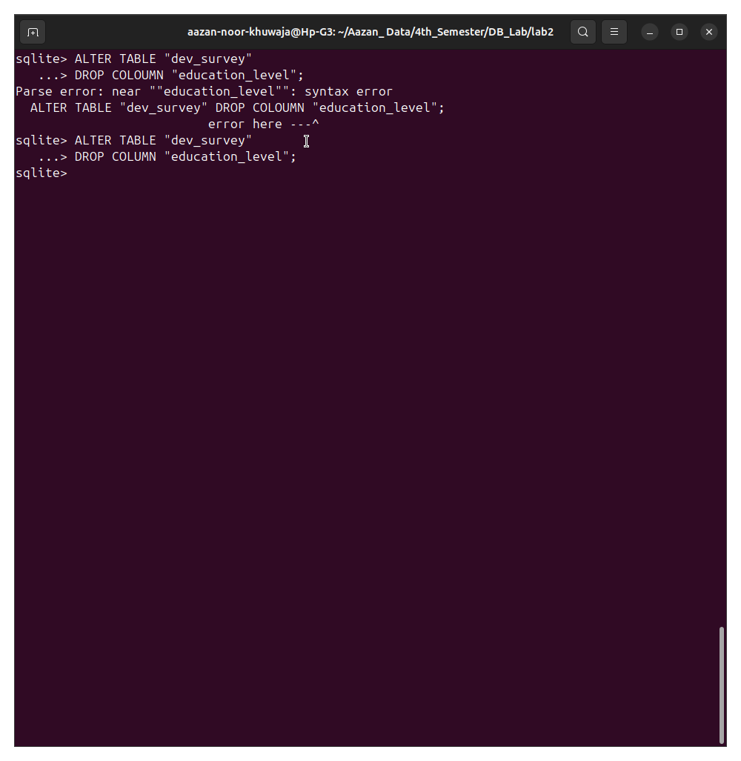

**Command:**

ALTER TABLE "dev_survey"

DROP COLUMN "education_level";

**Output:**

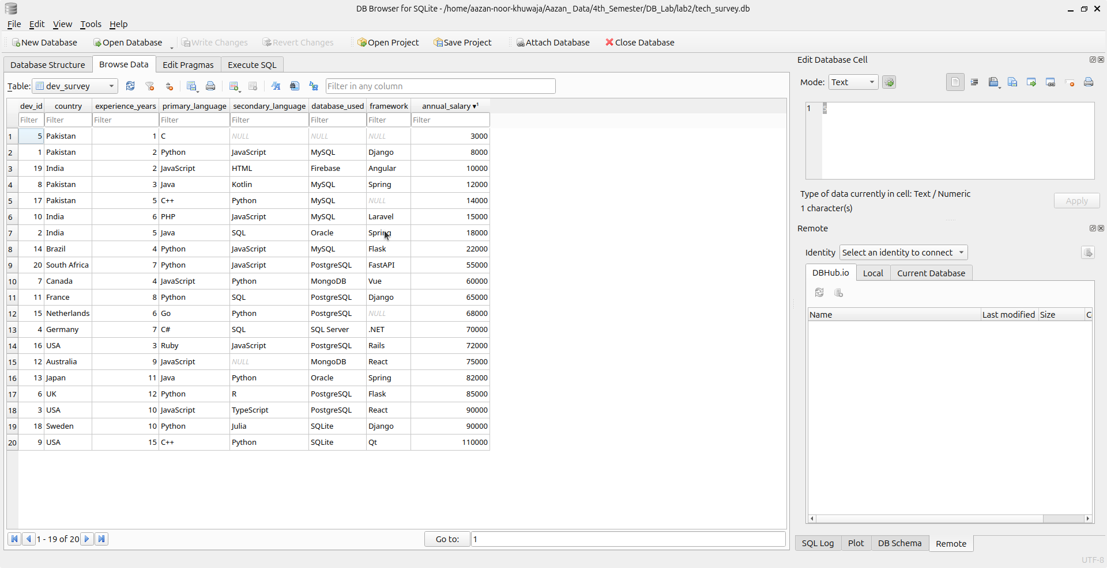

# **INSERT PART:**

1. **Insert all columns for one record:**

**Command Input:**

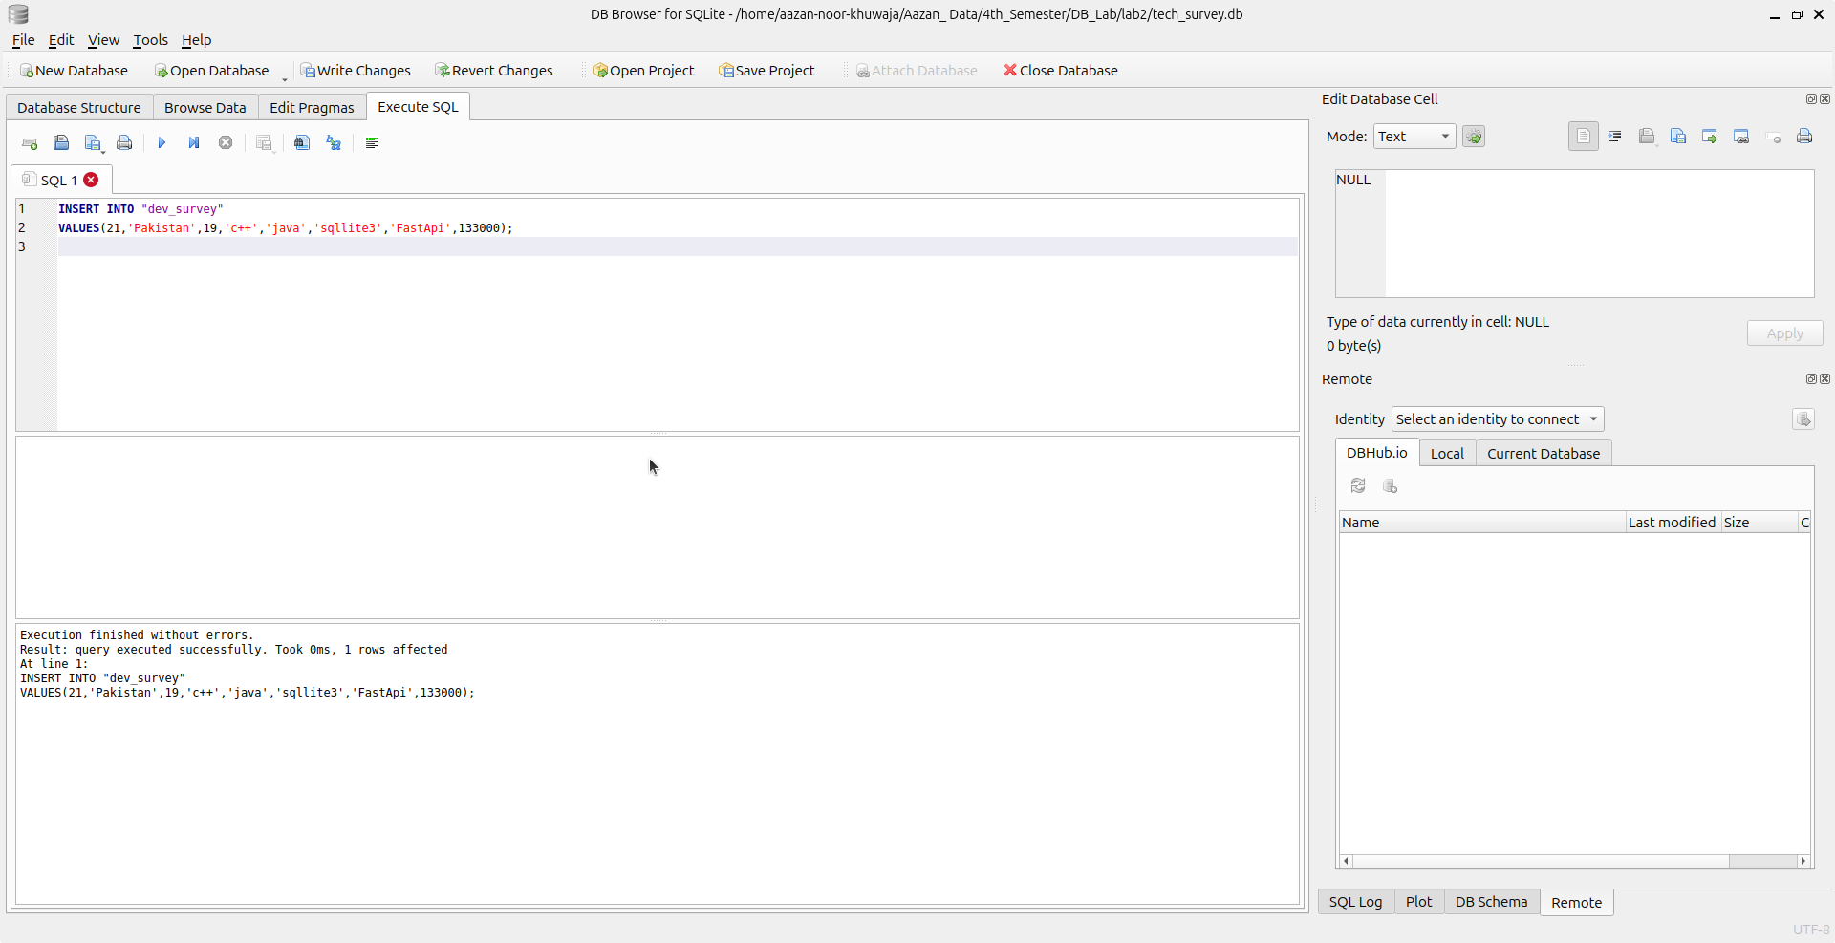

**Command:**

INSERT INTO "dev_survey"

VALUES(21,'Pakistan',19,'c++','java','sqllite3','FastApi',133000);

**Output:**

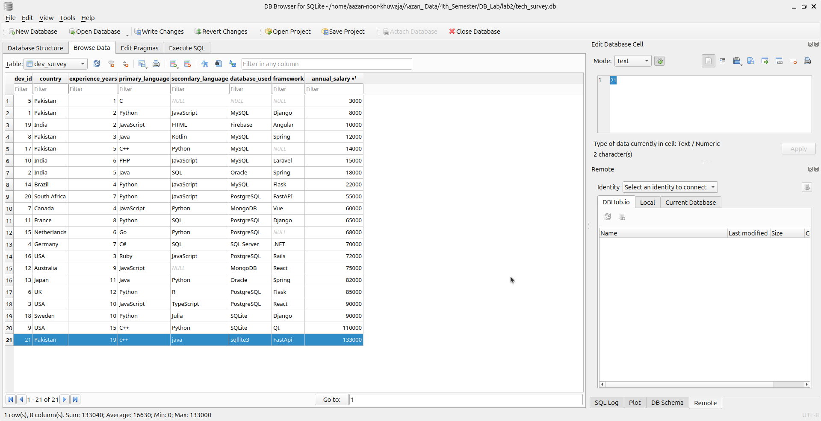

1. **Insert specific columns only for one record:**

**Command Input:**

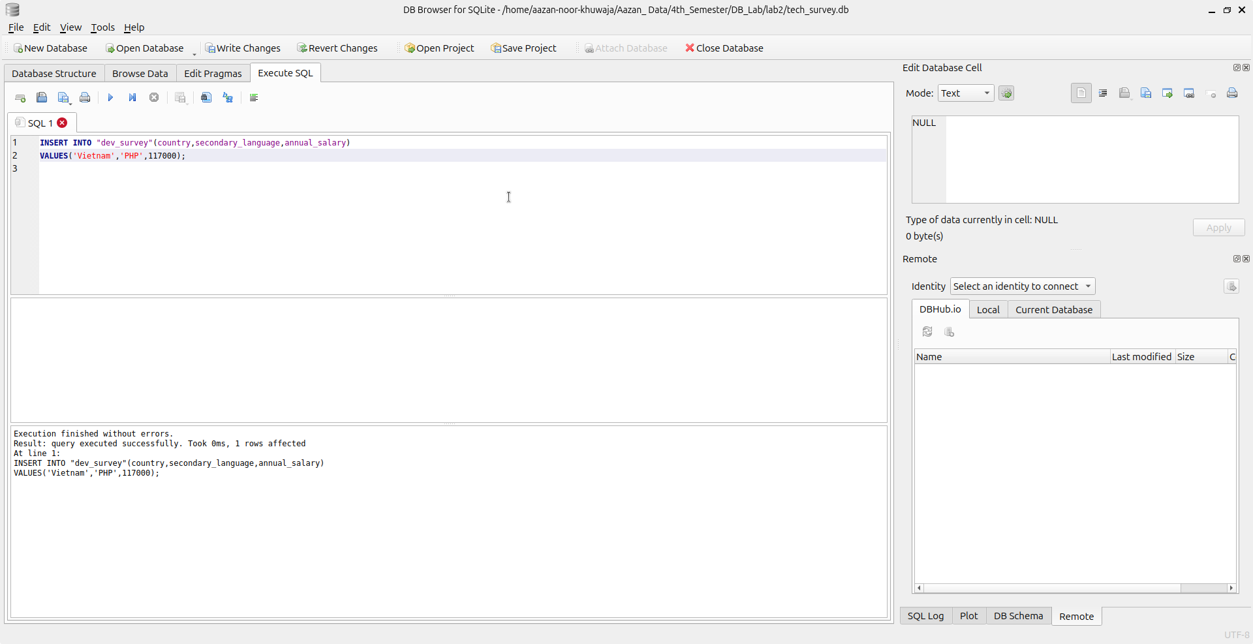

**Command:**

INSERT INTO "dev_survey"(country,secondary_language,annual_salary)

VALUES('Vietnam','PHP',117000);

**Output:**

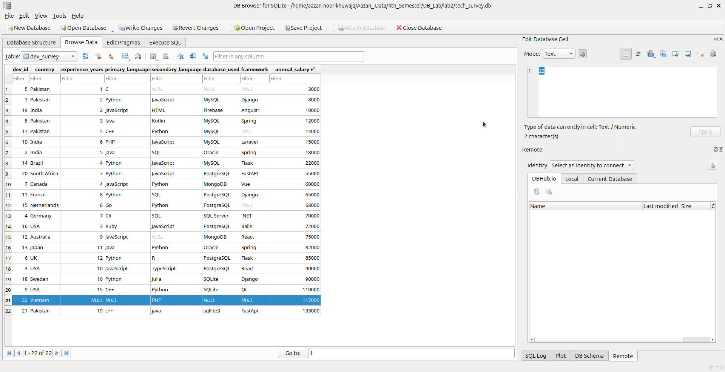

1. **Insert 3 rows in one statement:**

**Command Input:**

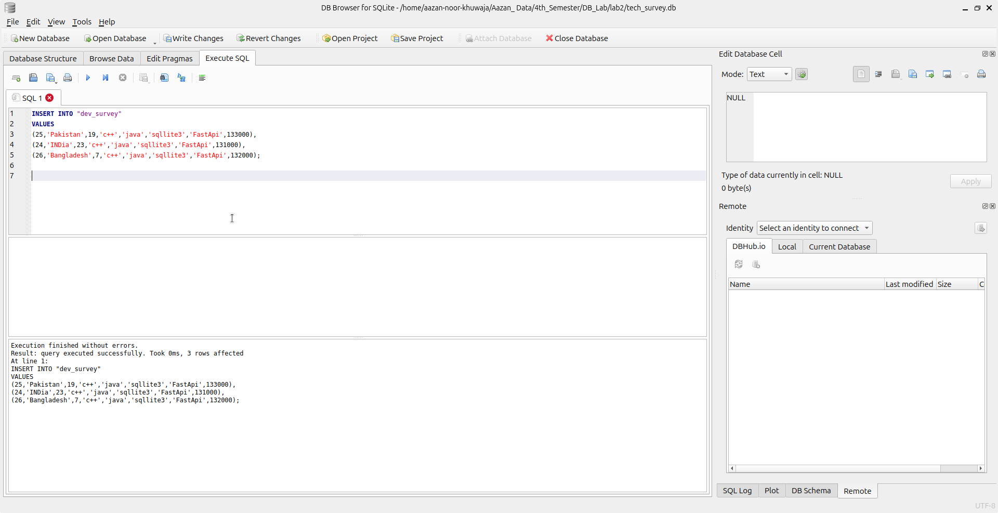

**Command:**

INSERT INTO "dev_survey"

VALUES

(25,'Pakistan',19,'c++','java','sqllite3','FastApi',133000),

(24,'INDia',23,'c++','java','sqllite3','FastApi',131000),

(26,'Bangladesh',7,'c++','java','sqllite3','FastApi',132000);

**Output:**

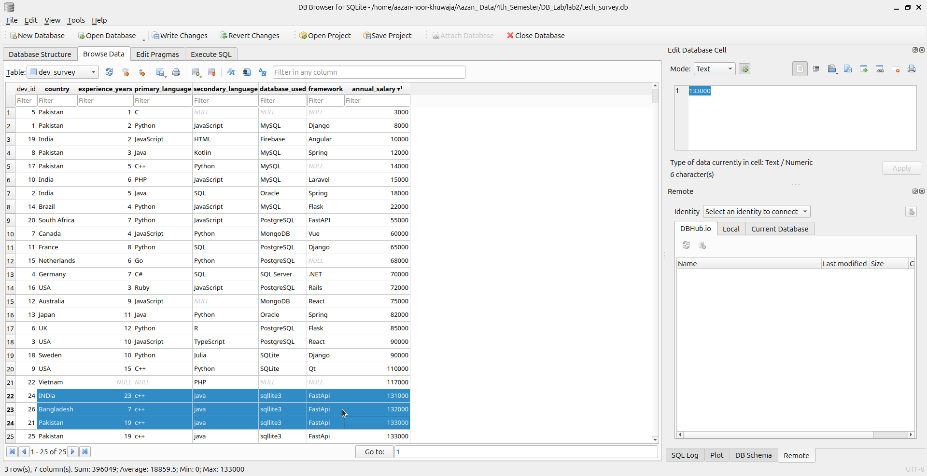

# **UPDATE PART:**

**1. Update salary of developers from Pakistan by +10%:**

**Command Input:**

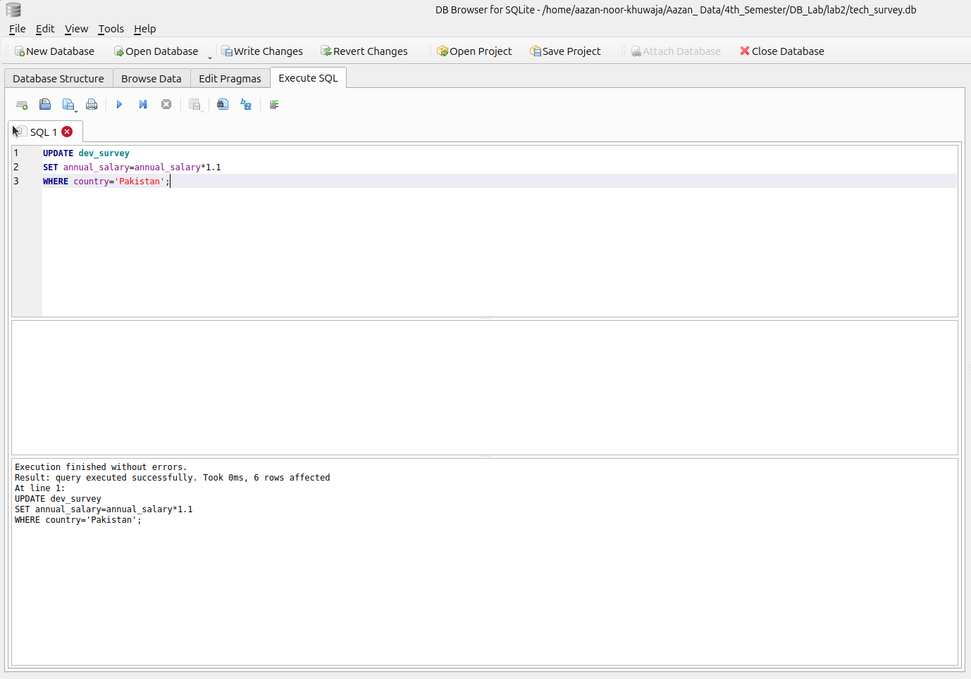

**Command:**

UPDATE dev_survey

SET annual_salary=annual_salary*1.1

WHERE country='Pakistan';

**Output:**

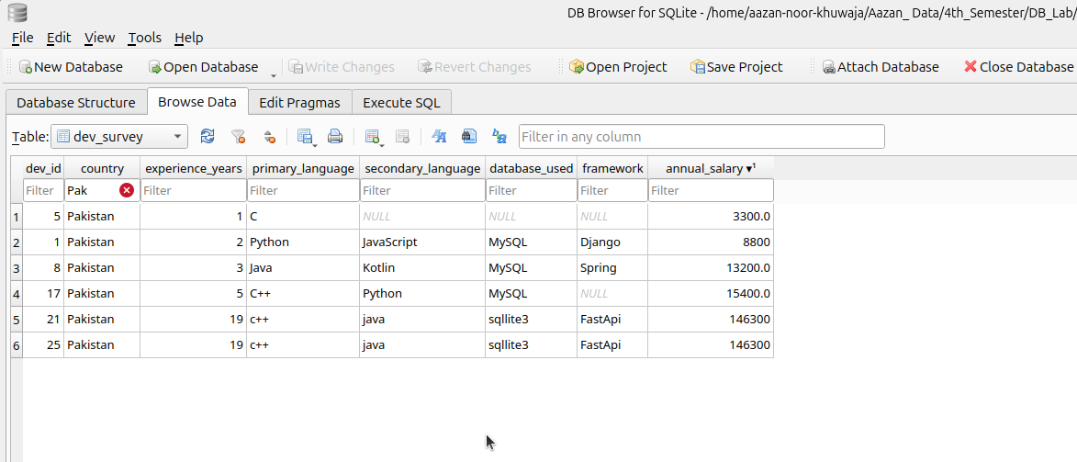

Figure 3 Before

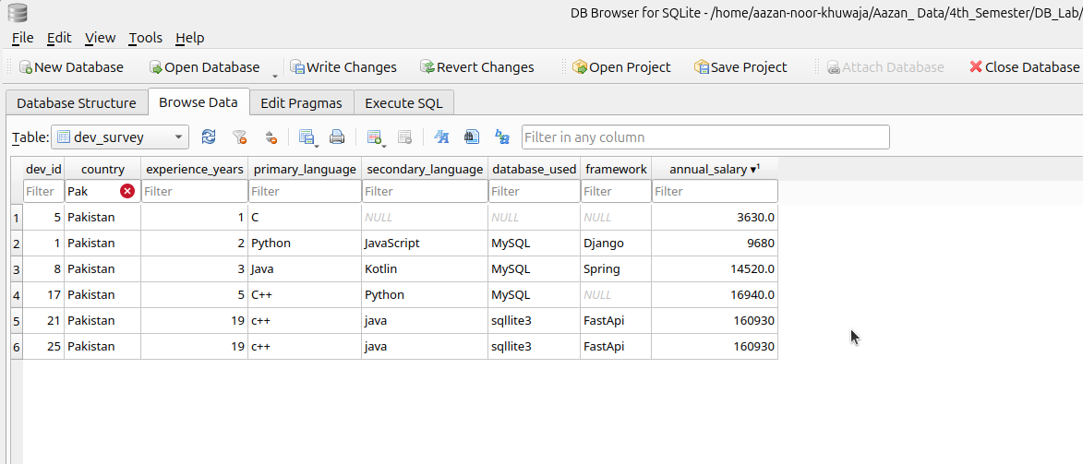

Figure 4 After

**2. Update framework to NULL where database_used is NULL:**

**Command Input:**

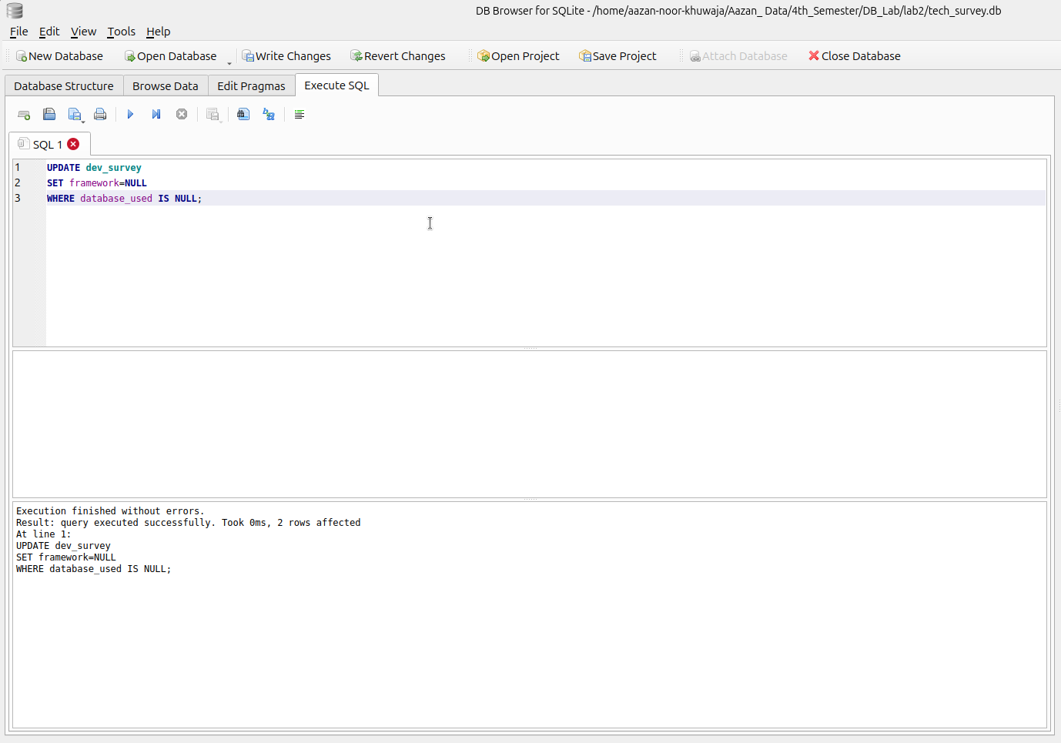

**Command:**

UPDATE dev_survey

SET framework=NULL

WHERE database_used IS NULL;

**Output:**

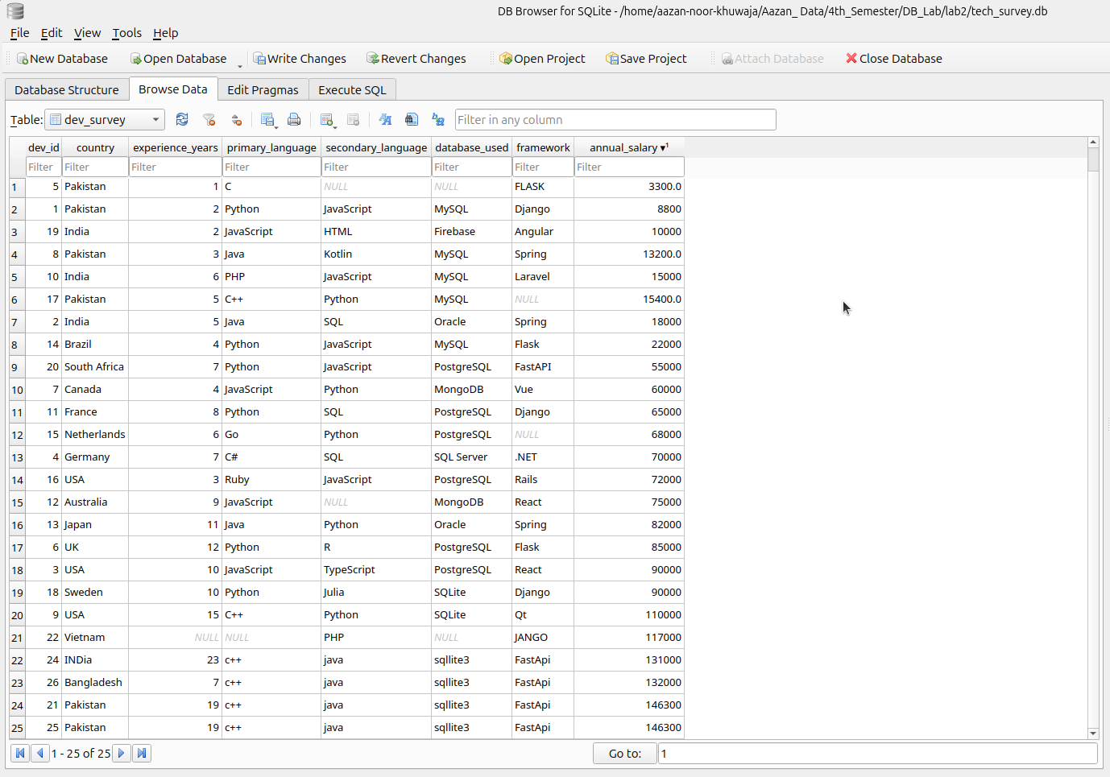

Figure 5 Before

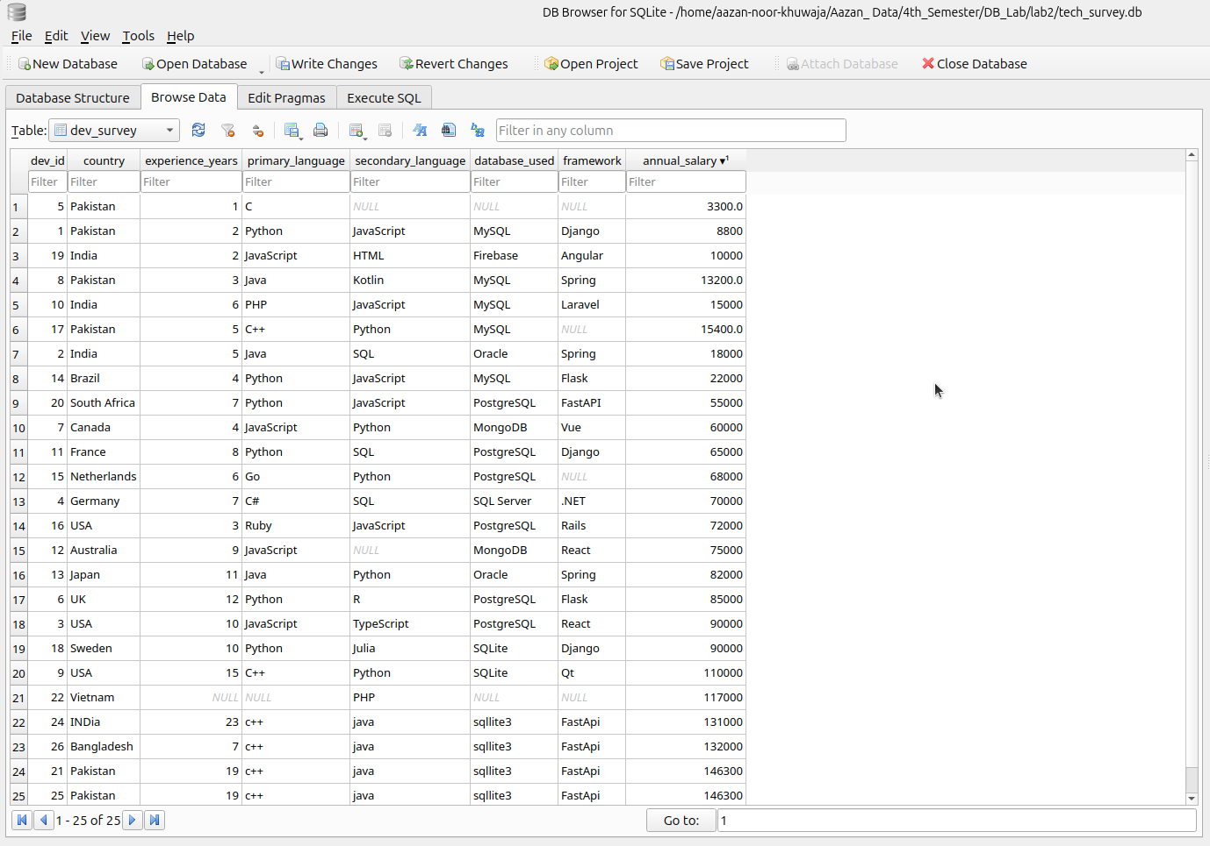

Figure 6 After

**3. Change the primary language of dev_id = 5 to Python:**

**Command Input:**

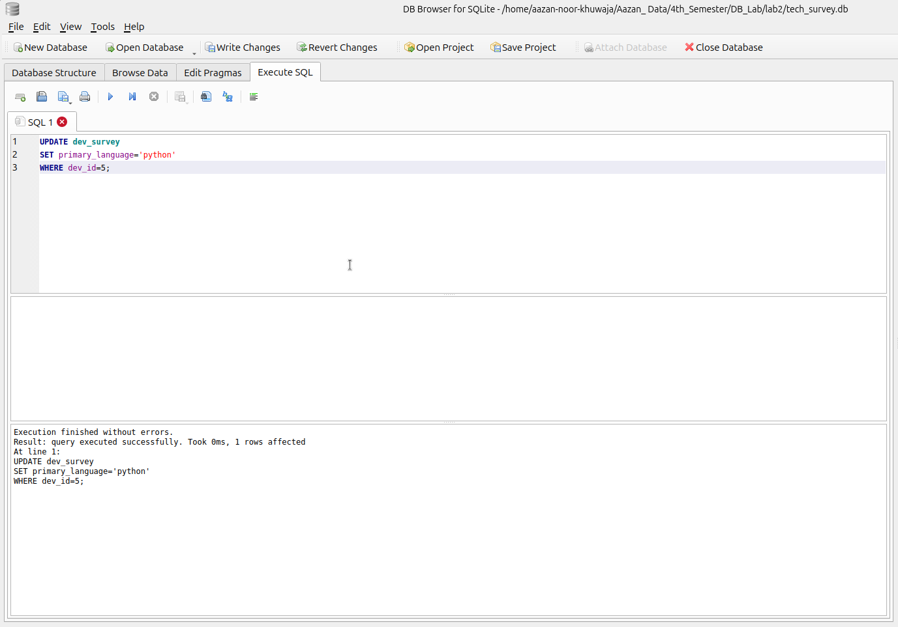

**Command:**

UPDATE dev_survey

SET primary_language='python'

WHERE dev_id=5;

**Output:**

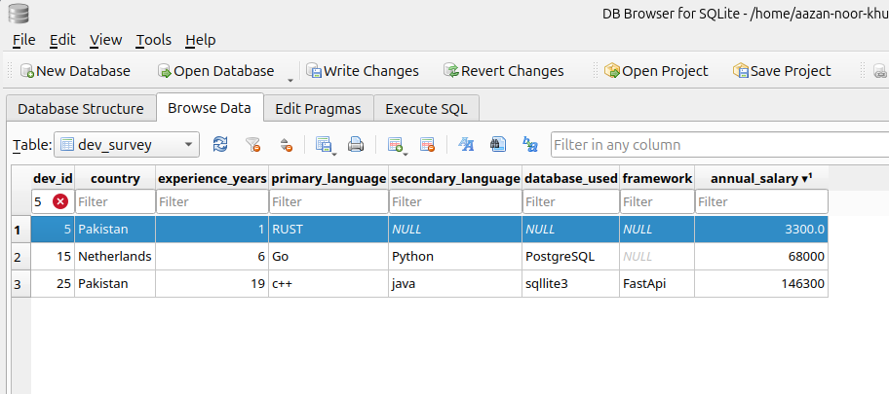

Figure 7 Before

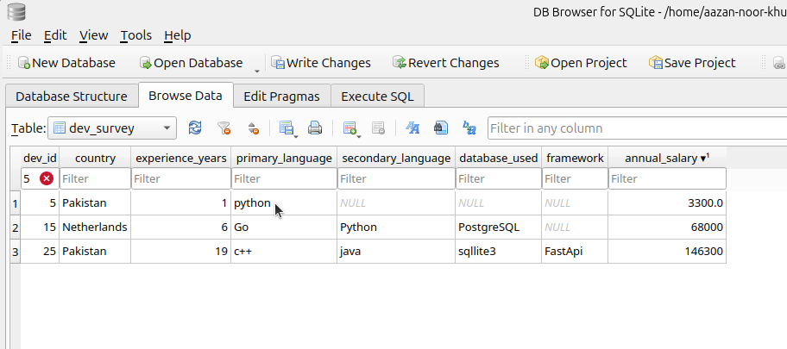

Figure 8 After

# **DELETE PART:**

**1. Delete developers with experience < 2 years:**

**Command Input:**

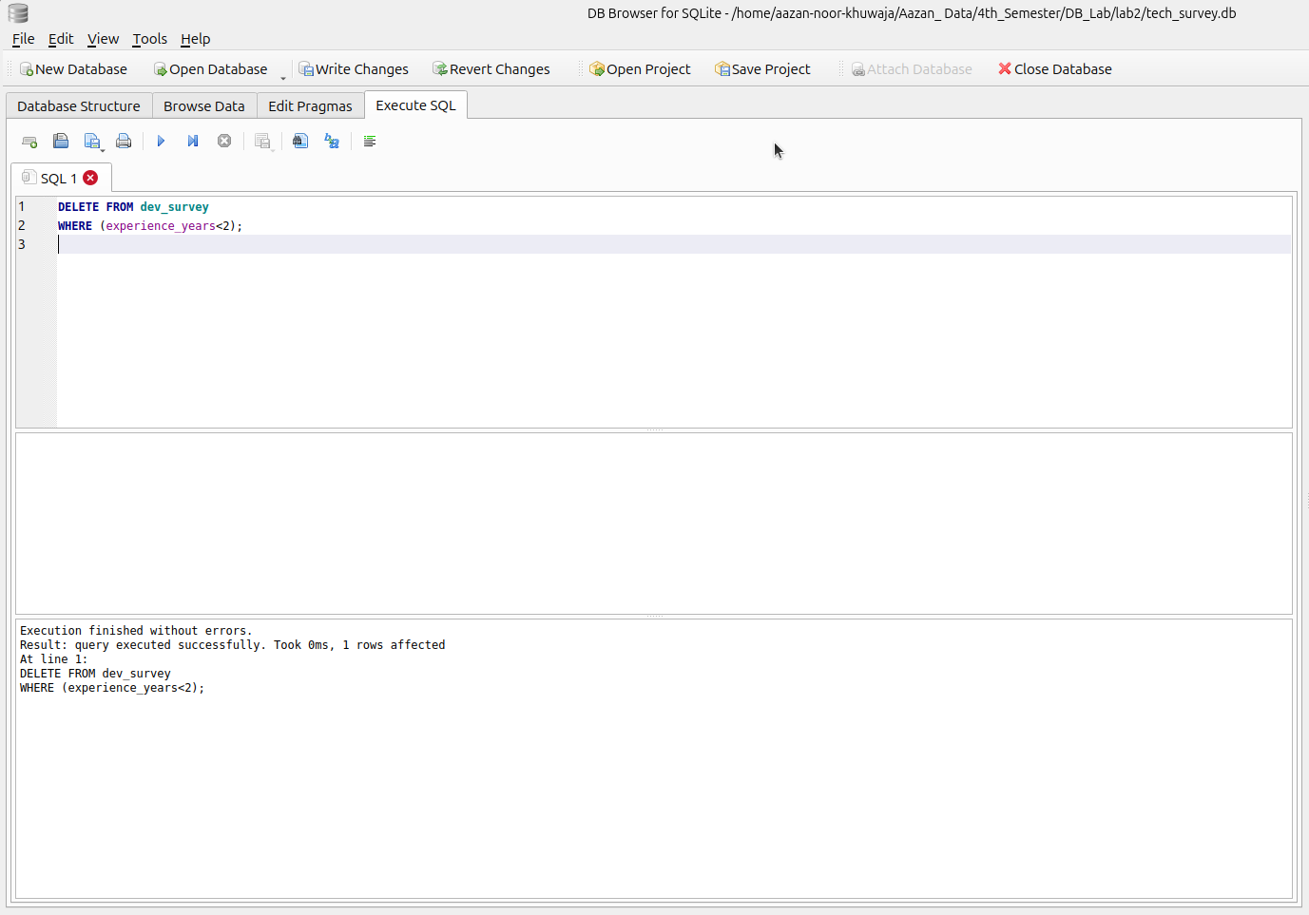

**Command:**

DELETE FROM dev_survey

WHERE (experience_years<2);

**Output:**

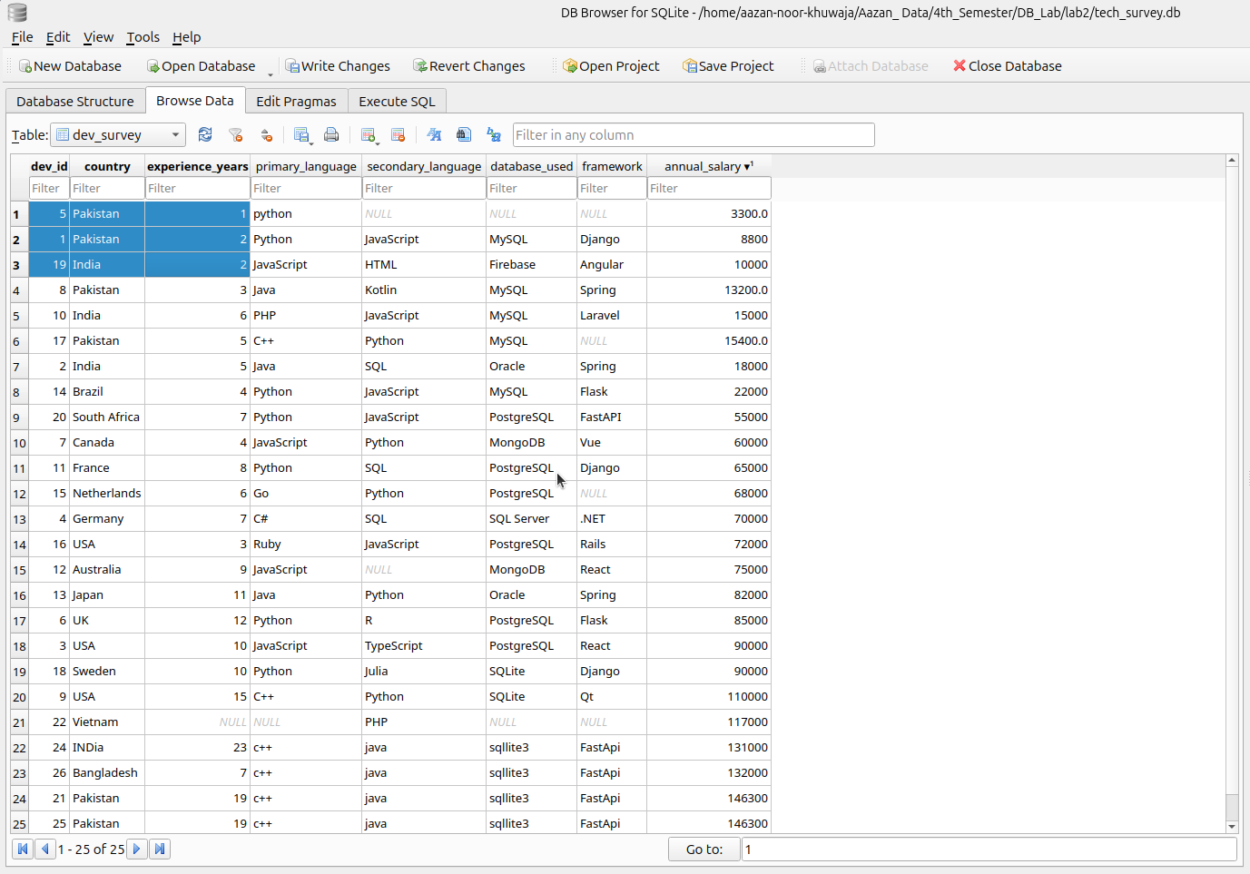

Figure 9 Before

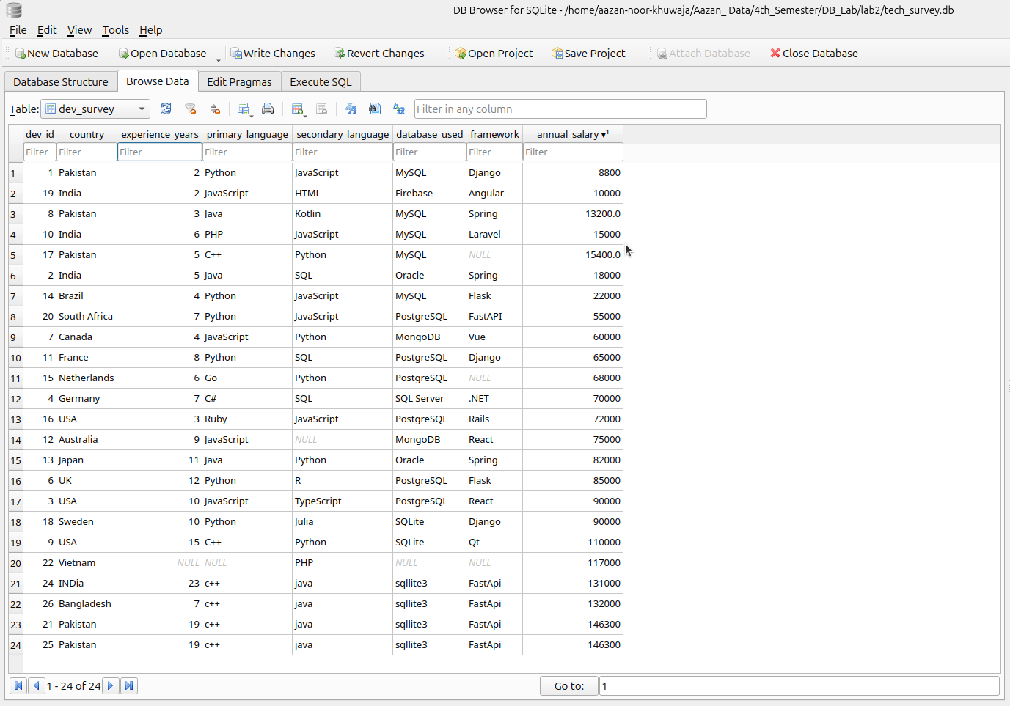

Figure 10 After

**2. Delete developers whose salary is NULL:**

**Command Input:**

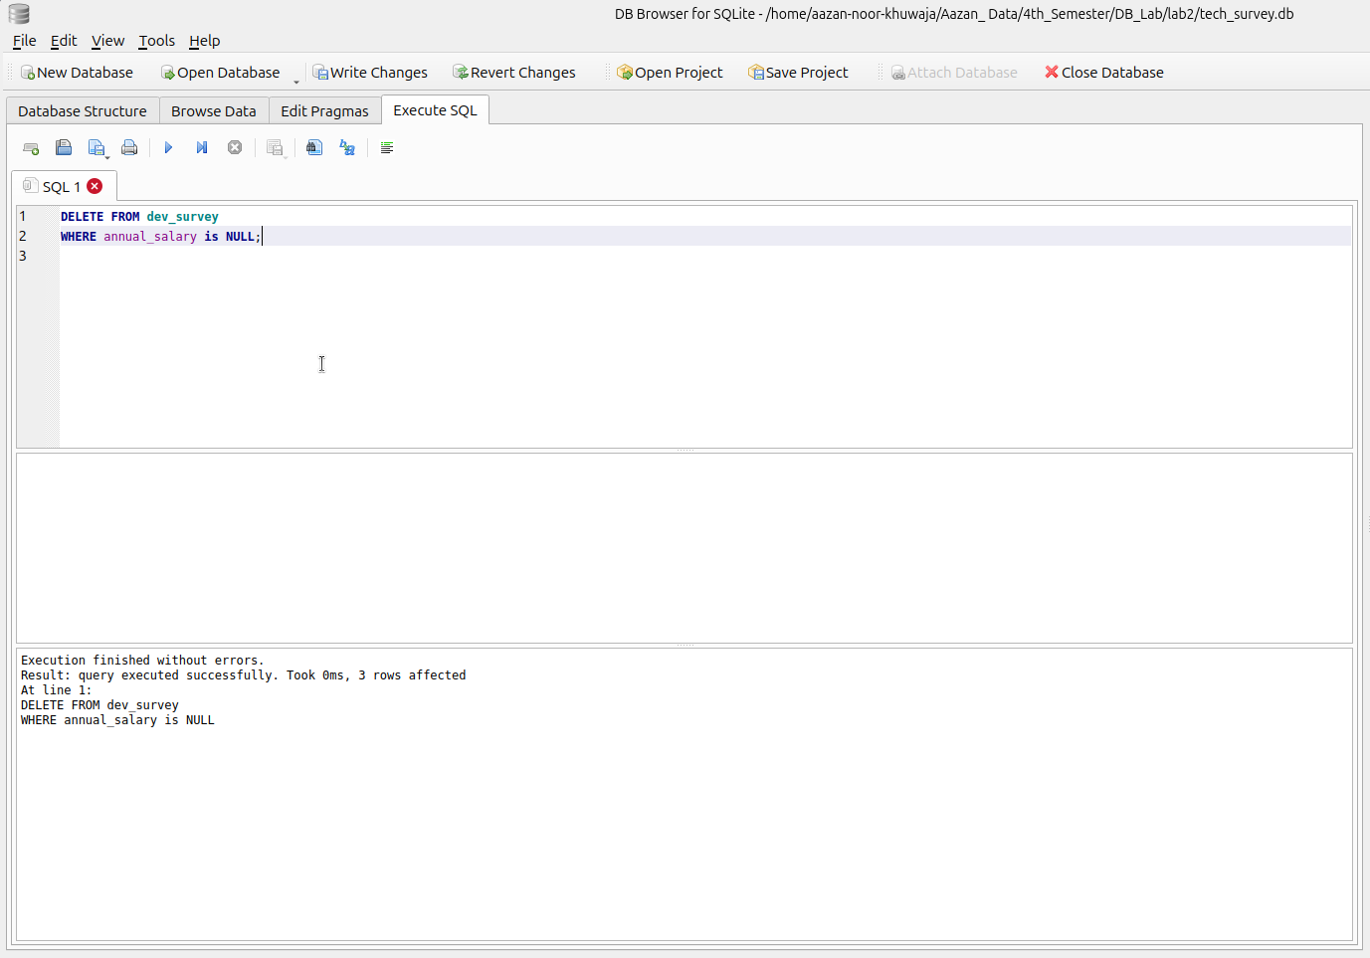

**Command:**

DELETE FROM dev_survey

WHERE annual_salary is NULL;

**Output:**

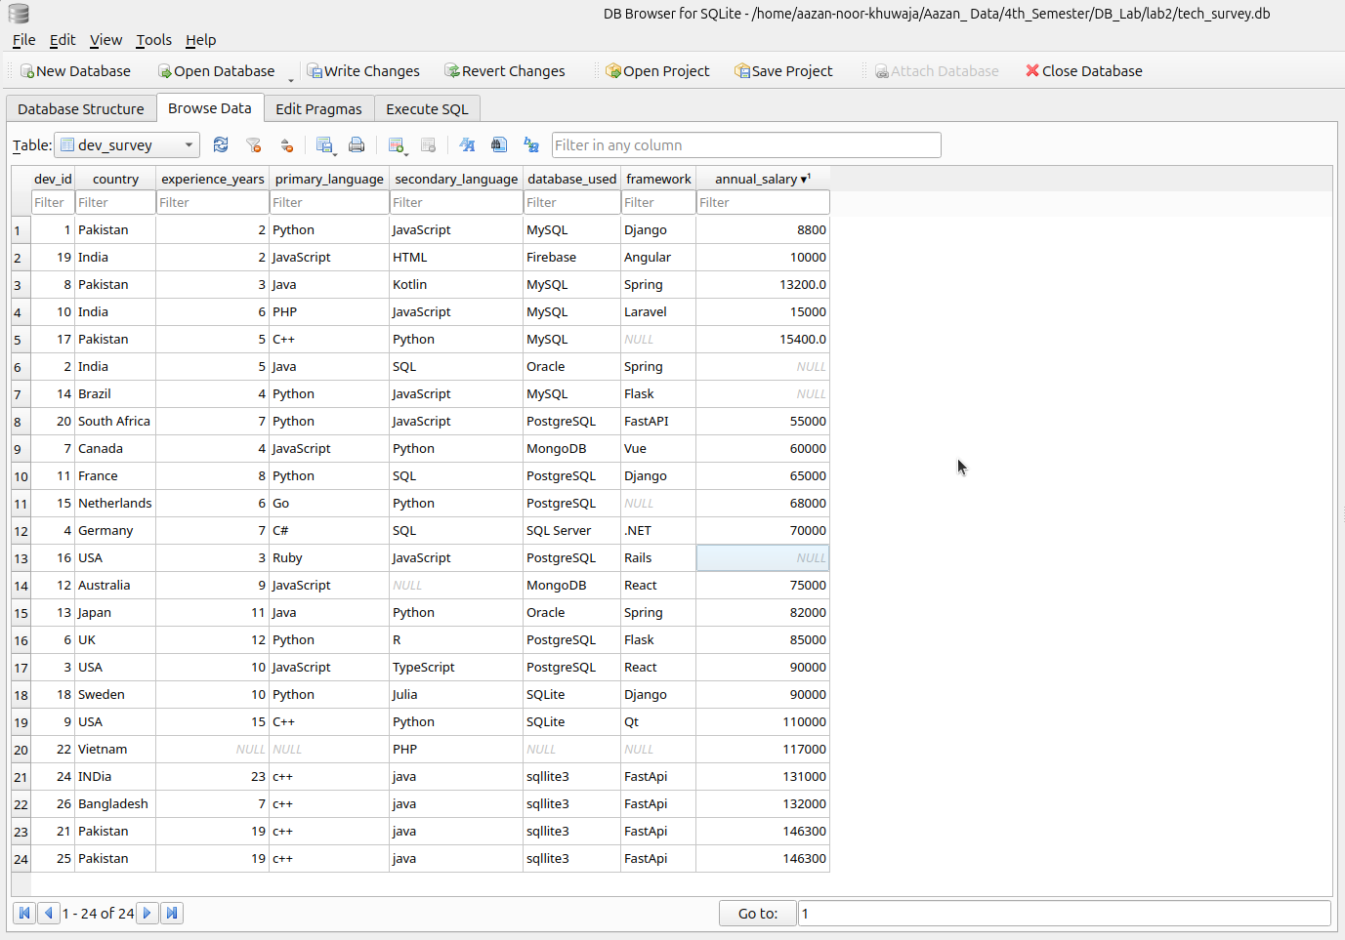

Figure 11 Before

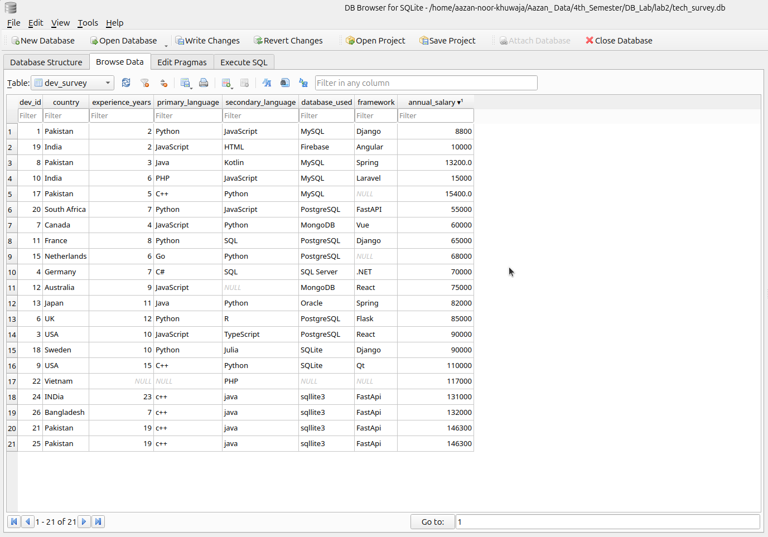

Figure 12 After

# **SELECT PART:**

**1. Display all developer records:**

**Command:**

SELECT * FROM dev_survey

**Output:**

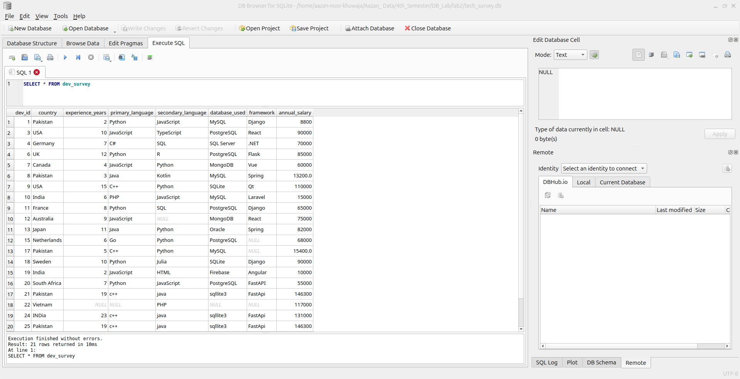

**2. Display only country, primary_language, annual_salary:**

**Command:**

SELECT country,primary_language,annual_salary FROM dev_survey;

**Output:**

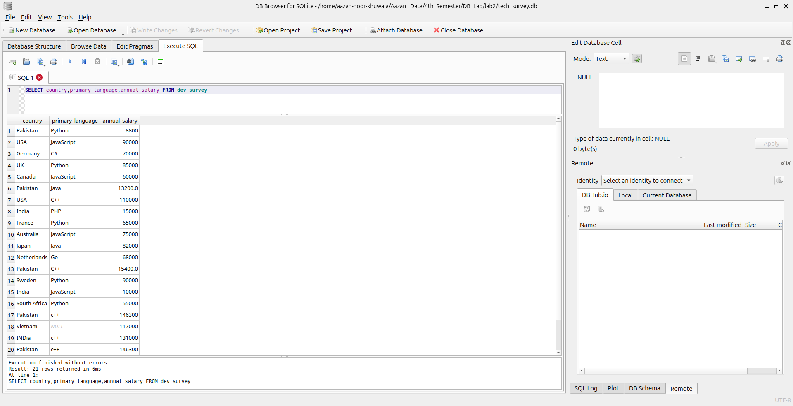

**3. List developers earning more than 50,000 USD:**

**Command:**

SELECT * FROM dev_survey

WHERE (annual_salary>50000);

**Output:**

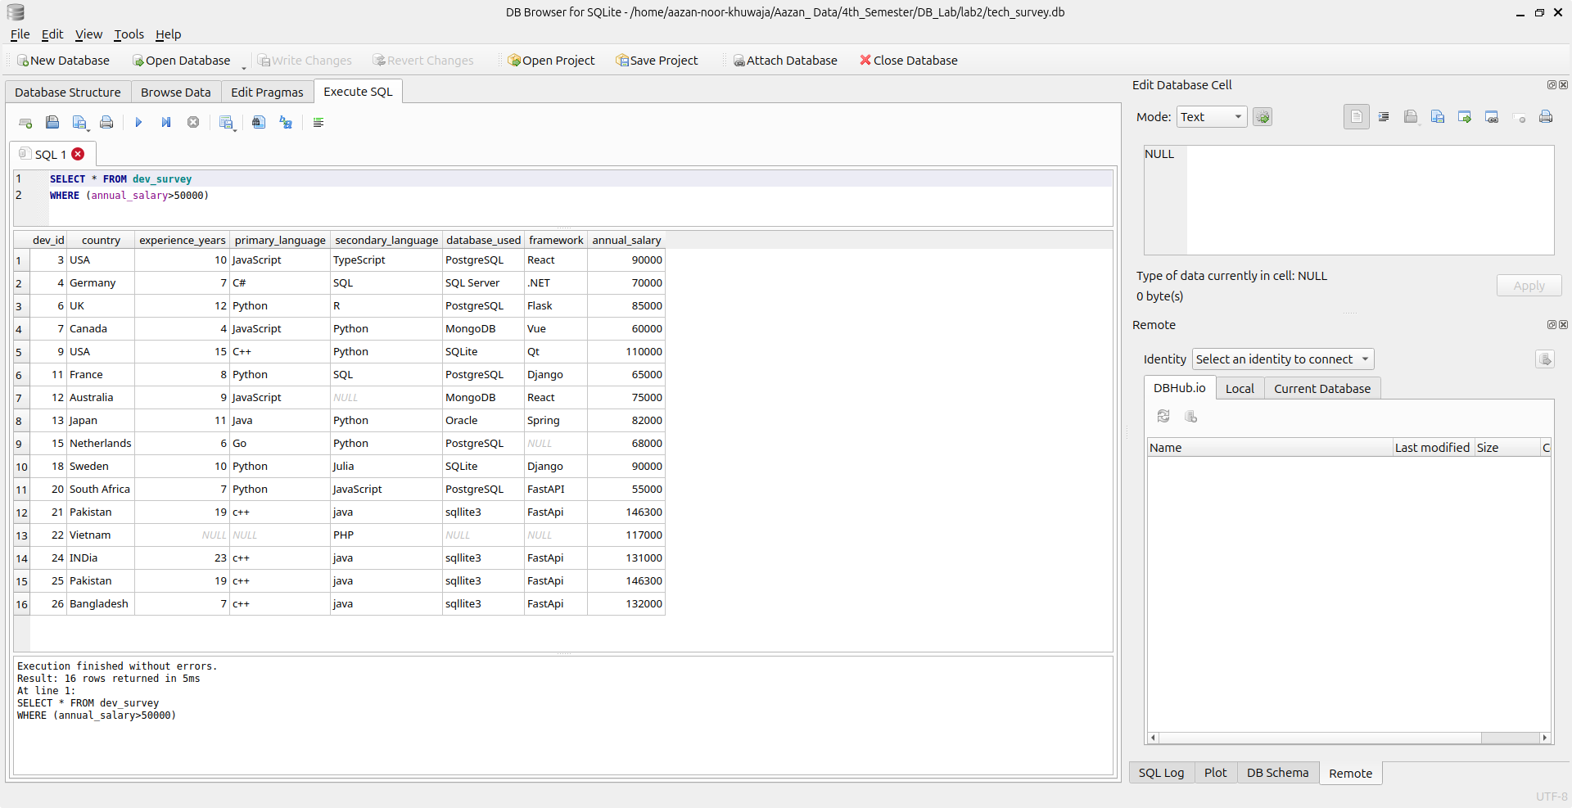

**4. List developers with experience between 3 and 8 years:**

**Command:**

SELECT * FROM dev_survey

WHERE experience_years BETWEEN 3 AND 8;

**Output:**

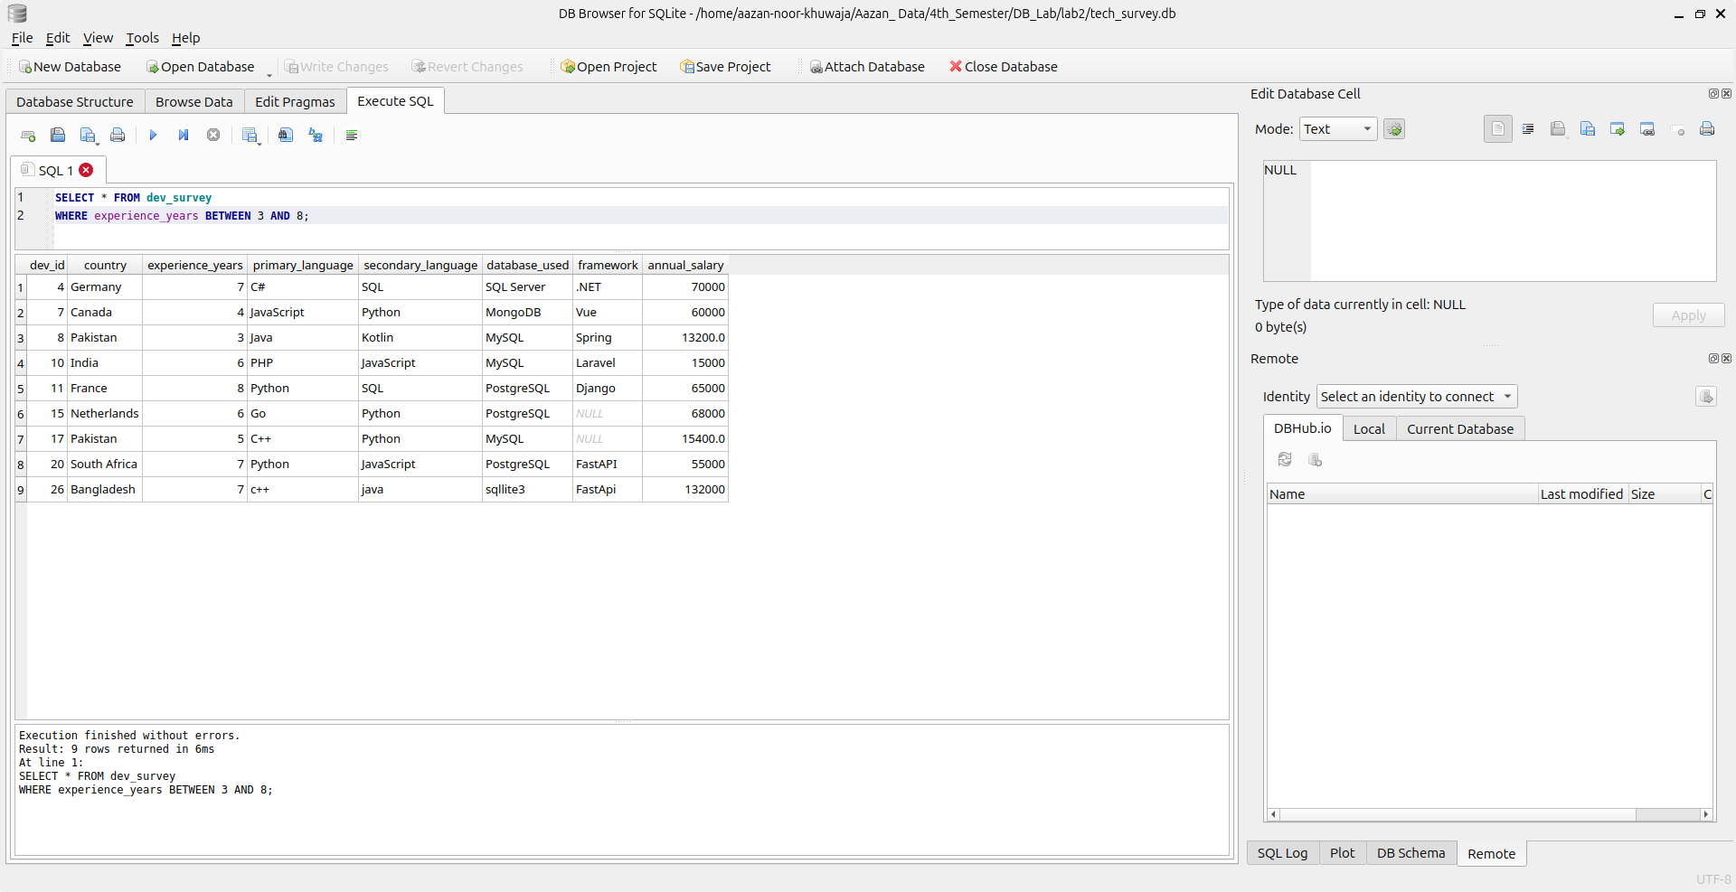

**5. Show developers from Pakistan earning less than 20,000 USD:**

**Command:**

SELECT * FROM dev_survey

WHERE country='Pakistan' AND annual_salary<20000;

**Output:**

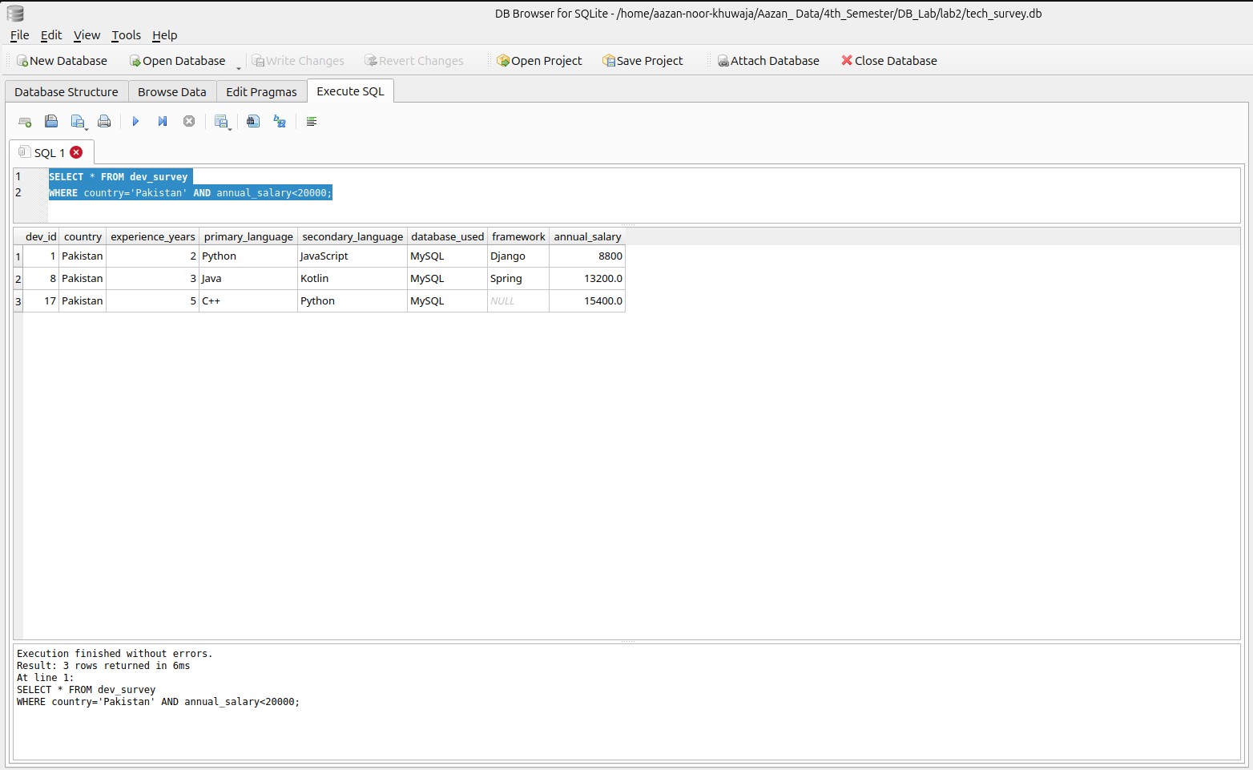

**6. Show developers who use Python and PostgreSQL:**

**Command:**

SELECT *

FROM dev_survey

WHERE primary_language = 'Python' AND database_used = 'PostgreSQL';

**Output:**

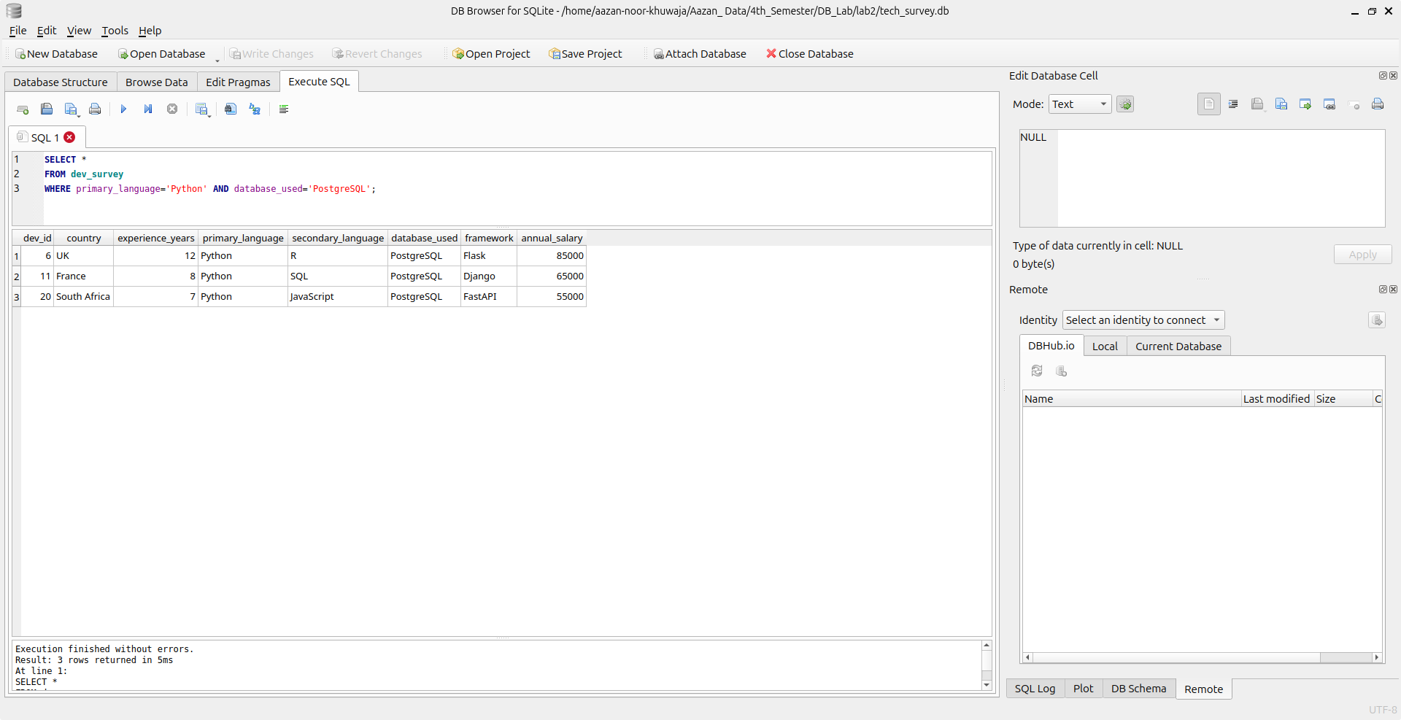

**7. Show developers from USA or Germany earning above 60,000 USD:**

**Command:**

SELECT *

FROM dev_survey

WHERE country = 'USA' OR country = 'Germany' AND annual_salary>60000;

**Output:**

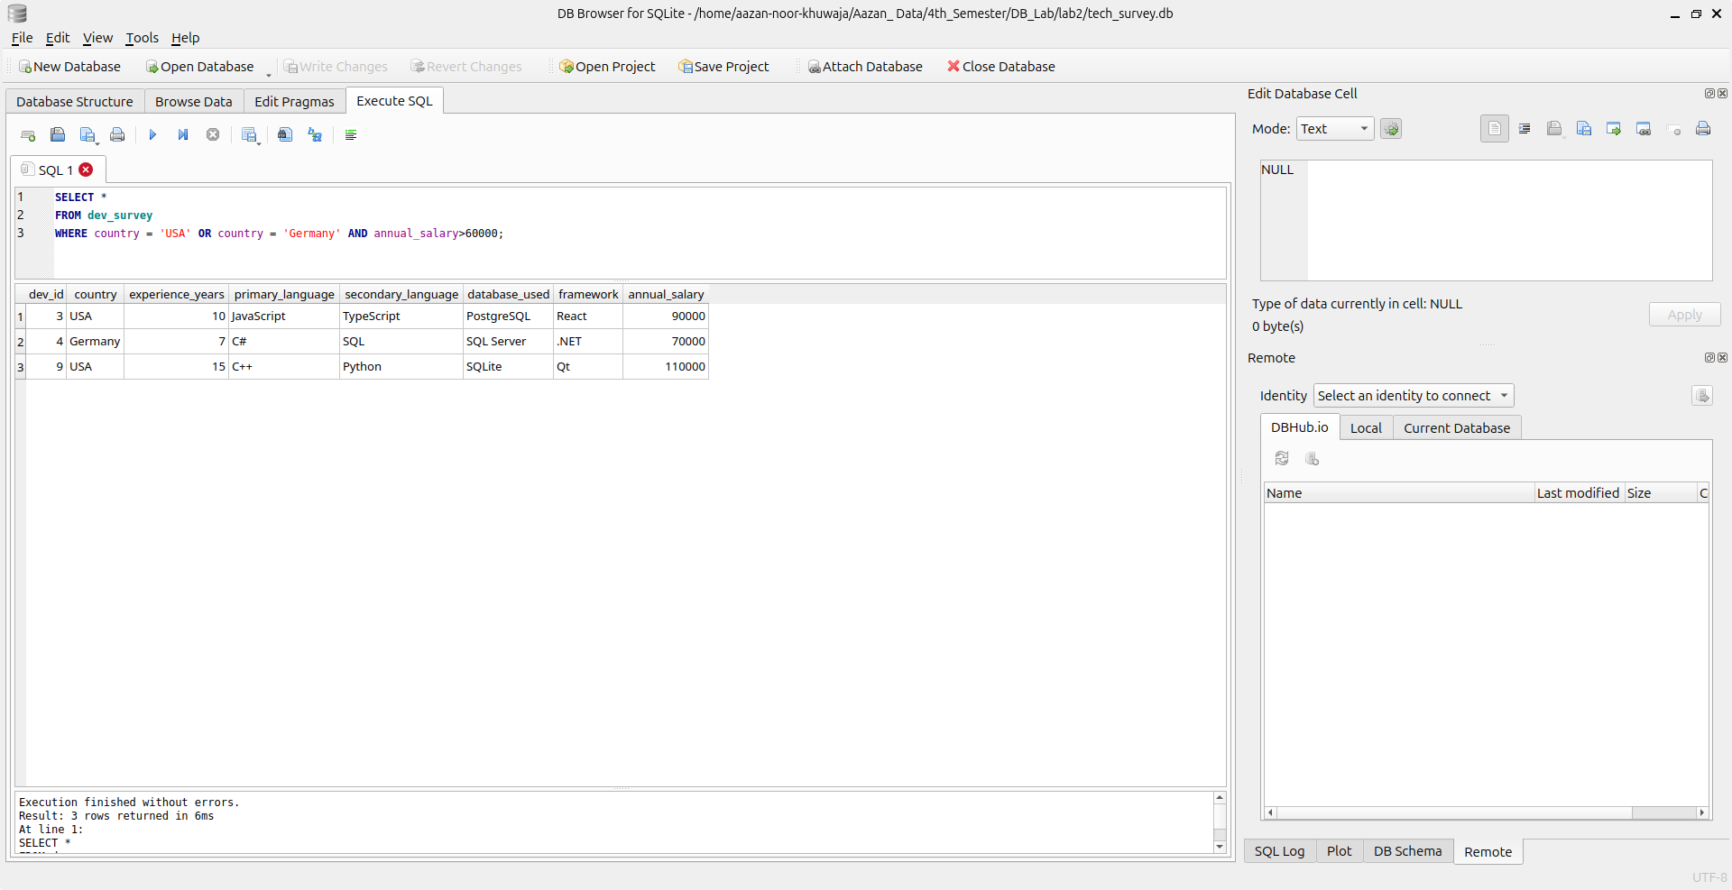

**8. Show developers who do not use JavaScript:**

**Command:**

SELECT *

FROM dev_survey

WHERE primary_language!='JavaScript';

**Output:**

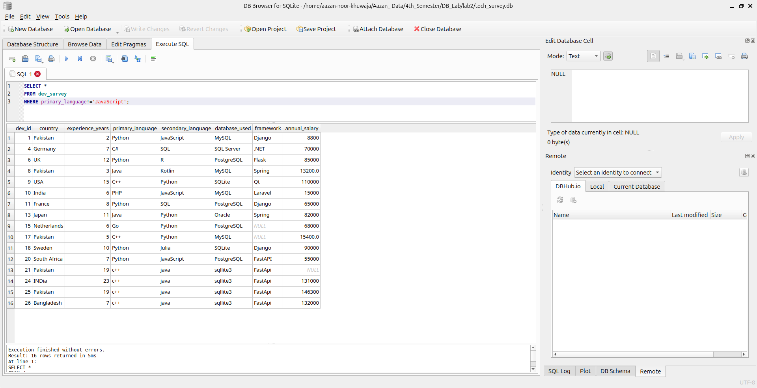

**9. Show developers with experience between 5 and 10 years:**

**Command:**

SELECT *

FROM dev_survey

WHERE experience_years BETWEEN 5 AND 10;

**Output:**

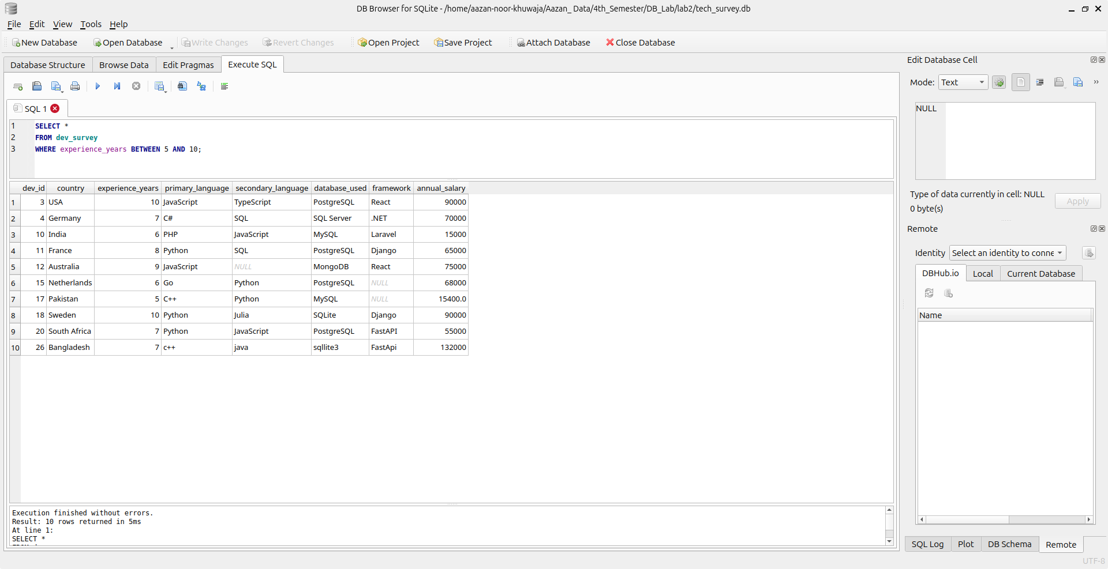

**10. Show developers whose primary language is either one of Python, Java, C++,PHP:**

**Command:**

SELECT *

FROM dev_survey

WHERE primary_language IN ('Python','Java','C++','PHP');

**Output:**

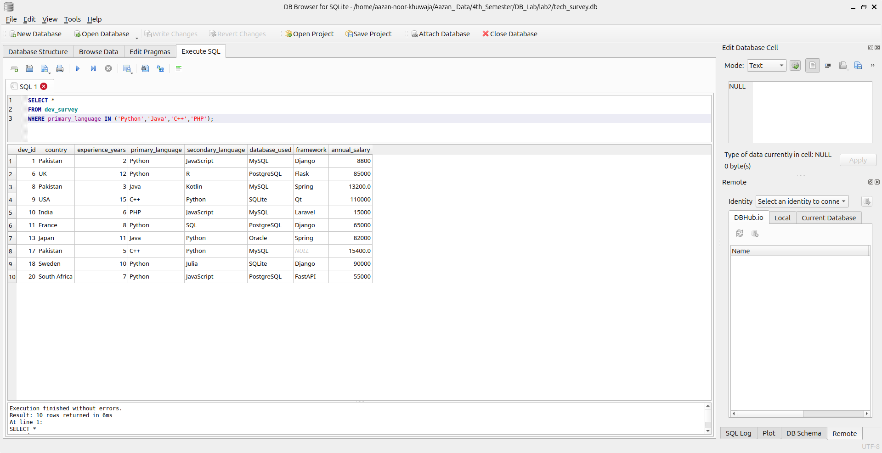

**11. Show developers whose framework starts with S:**

Command:

SELECT *

FROM dev_survey

WHERE framework LIKE 'S%';

**Output:**

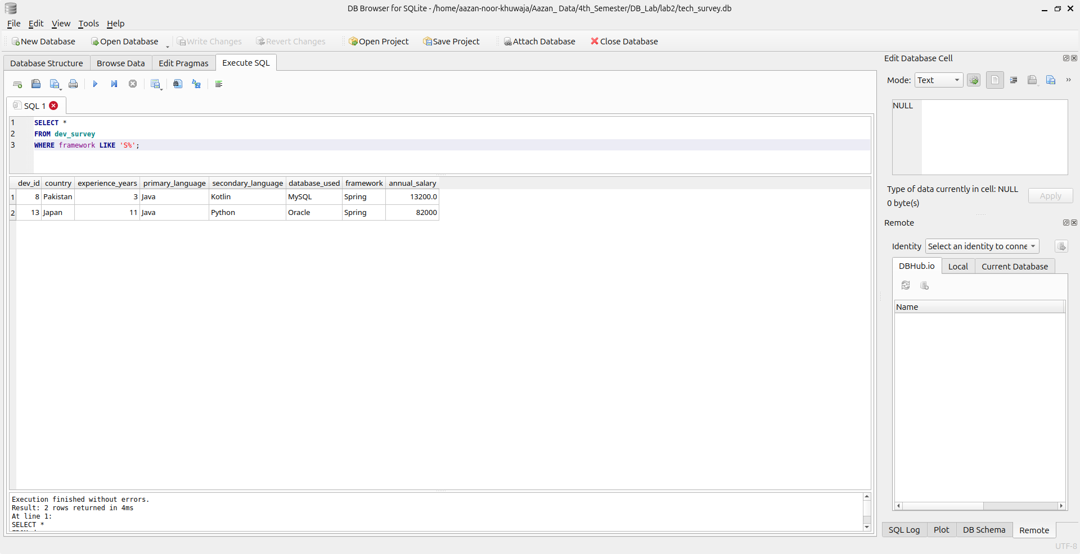

**12. Show developers whose database contains the word SQL:**

**Command:**

SELECT *

FROM dev_survey

WHERE database_used LIKE '%SQL%';

**Output:**

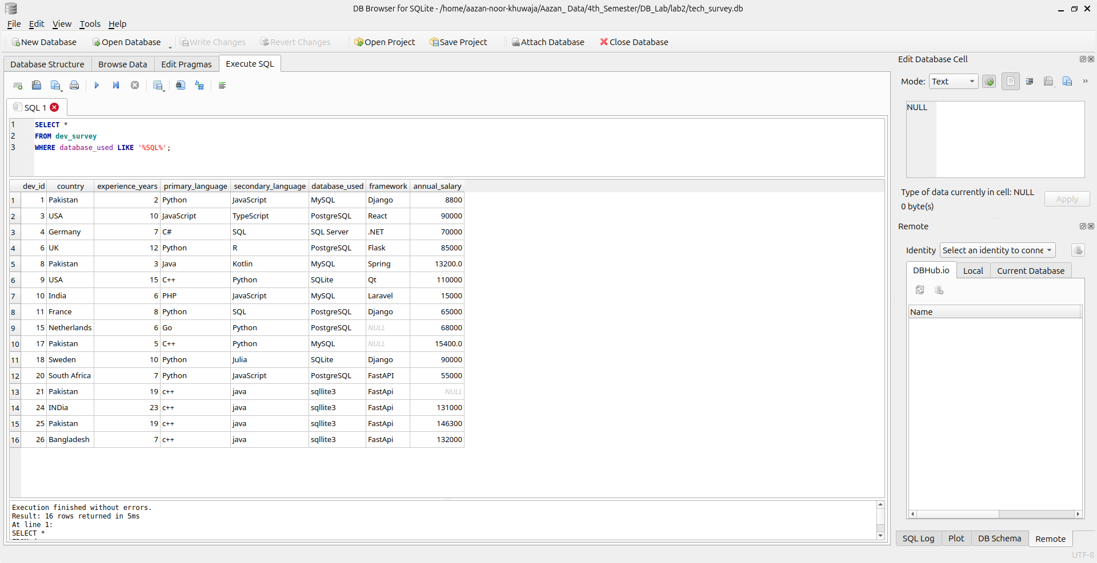

**13. Show the top 5 highest-paid developers:**

**Command:**

SELECT *

FROM dev_survey

ORDER BY annual_salary DESC

LIMIT 5;

**Output:**

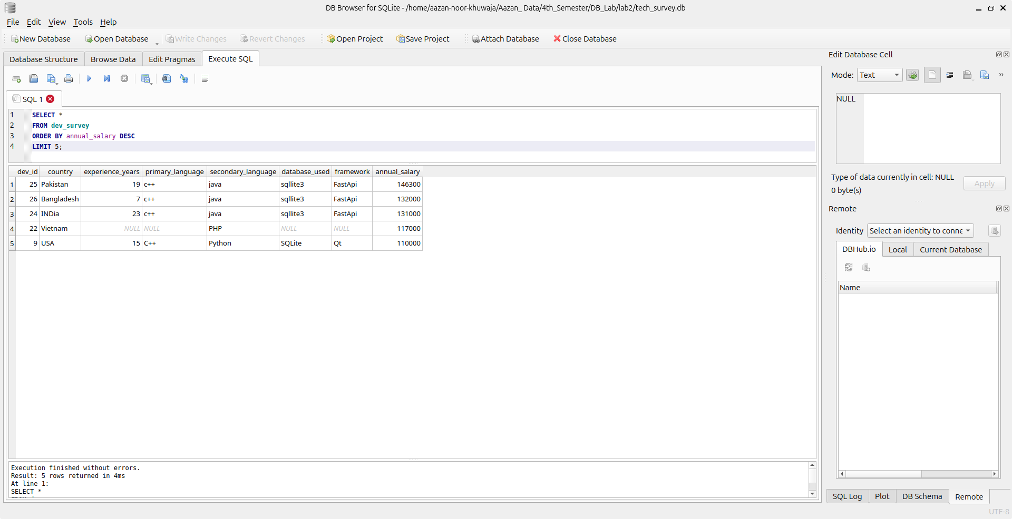

**14. Show the lowest-paid developers sorted by salary:**

**Command:**

SELECT *

FROM dev_survey

ORDER BY annual_salary ASC;

**Output:**

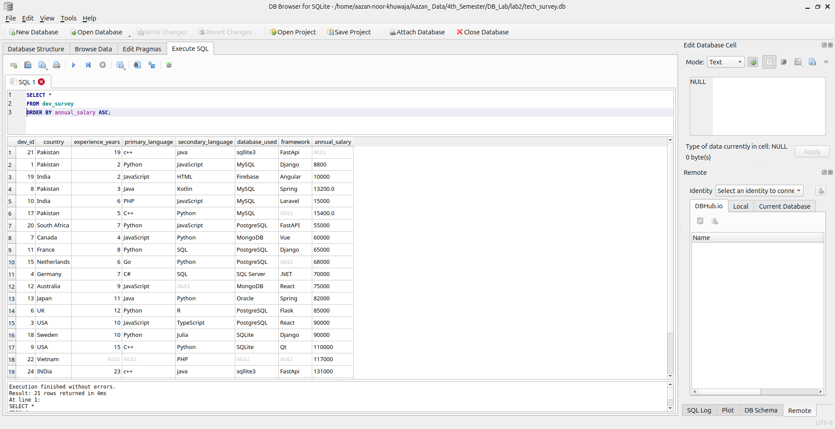

**15. Show the only developer with the most experience:**

**Command:**

SELECT *

FROM dev_survey

ORDER BY experience DESC

LIMIT 1;

**Output:**

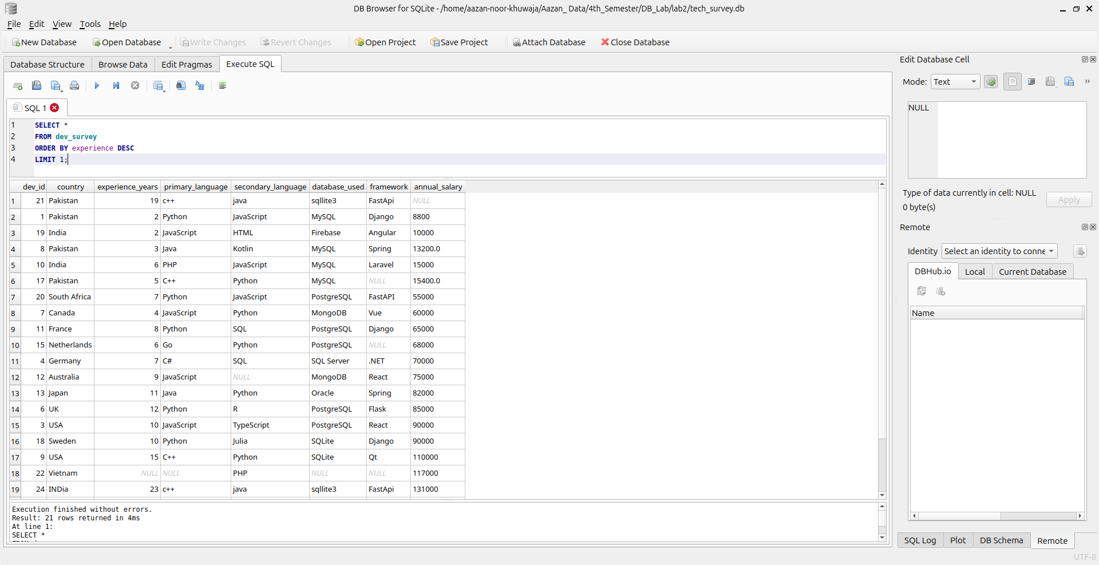

**16. Show developers who use both primary and secondary languages:**

**Command:**

SELECT *

FROM dev_survey

WHERE primary_language IS NOT NULL AND secondary_language IS NOT NULL;

**Output:**

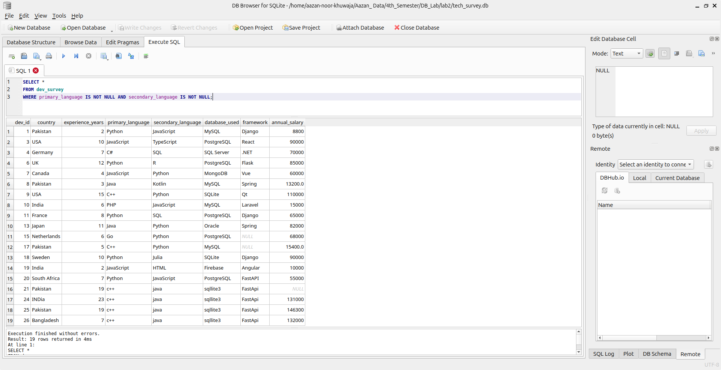

**17. Show developers where salary is not provided:**

**Command:**

SELECT *

FROM dev_survey

WHERE annual_salary IS NULL;

**Output:**

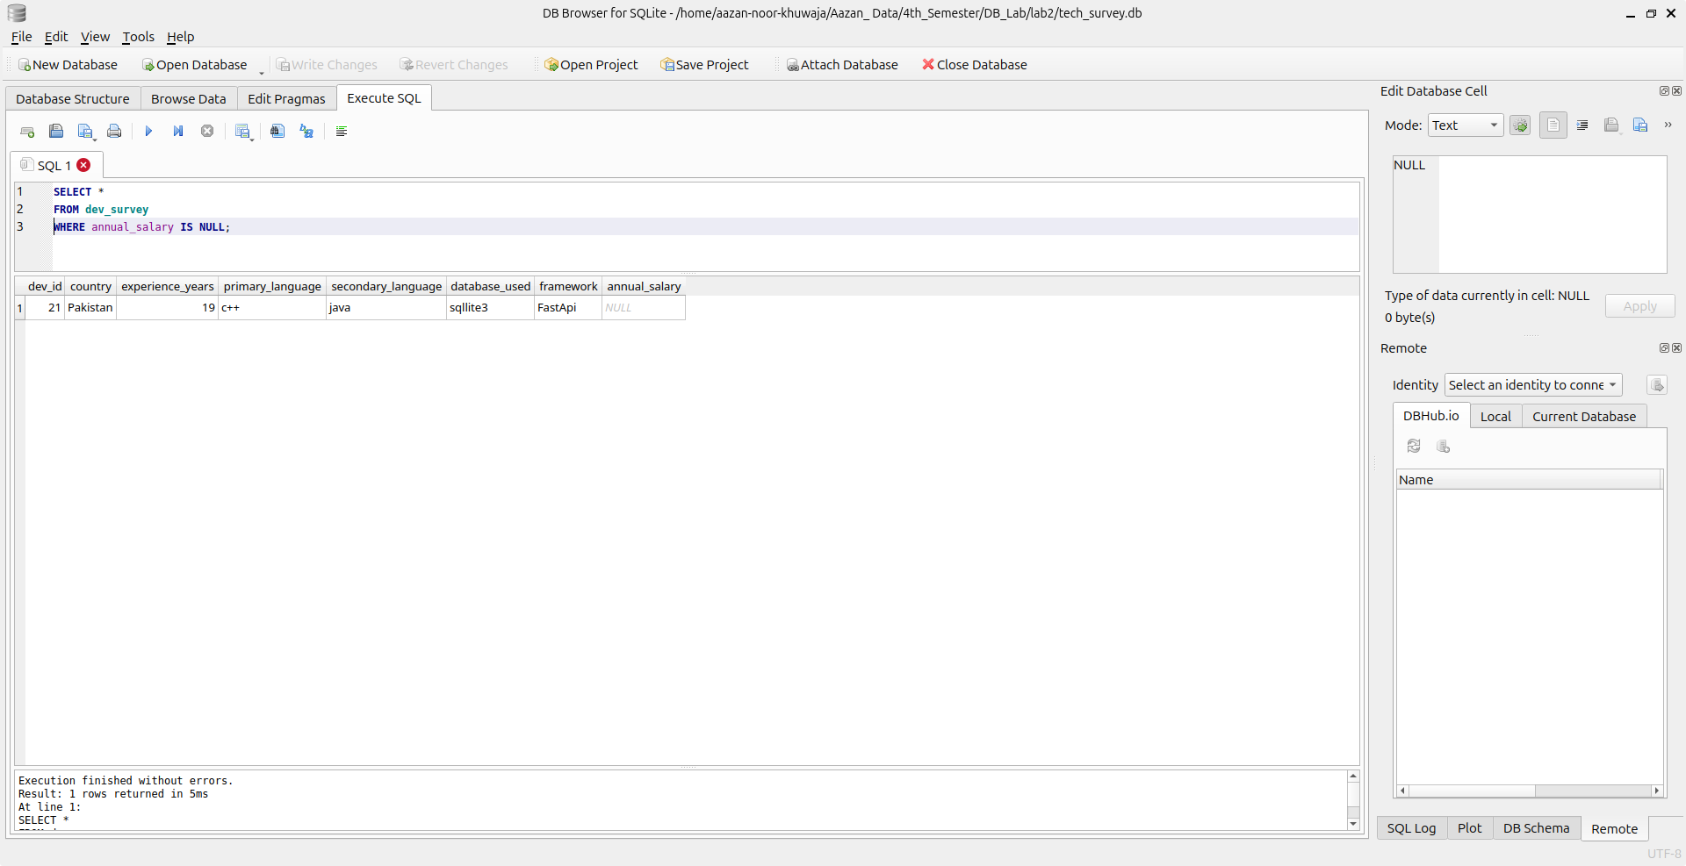

**18. Rank developers by salary within each country (sort based on two columns):**

**Command:**

SELECT *

FROM dev_survey

ORDER BY country ASC,annual_salary DESC;

**Output:**

